**React Native :**

**Environment setup:**

Android Studio, JDK, Node JS, VS Code

**Creating an expo cli command:**

npm install --global expo-cli

**New project using Expo:**

npx create-expo-app my-app

npx expo run:android

**Run the project**

**In Android emulator:**

npm run android (or)

npm start ----> a

**In Expo Go app in Mobile:**

npm start ----> Scan QR code from mobile app

**Icons:**

npm install --save react-native-vector-icons

List of icons link: https://oblador.github.io/react-native-vector-icons/

**Navigation:**

npm install @react-navigation/native

npm install react-native-screens react-native-safe-area-context

**Stack navigation:**

npm install @react-navigation/native-stack

**Async storage:**

npm install @react-native-async-storage/async-storage

**Camera:**

**To take pictures -**

**Cmd:** expo install expo-camera

**To share pictures -**

**Cmd:** expo install expo-sharing

**To save pictures in camera gallery -**

**Cmd:** expo install expo-media-library

**Sample ToDo List App Output:**

Welcome page:

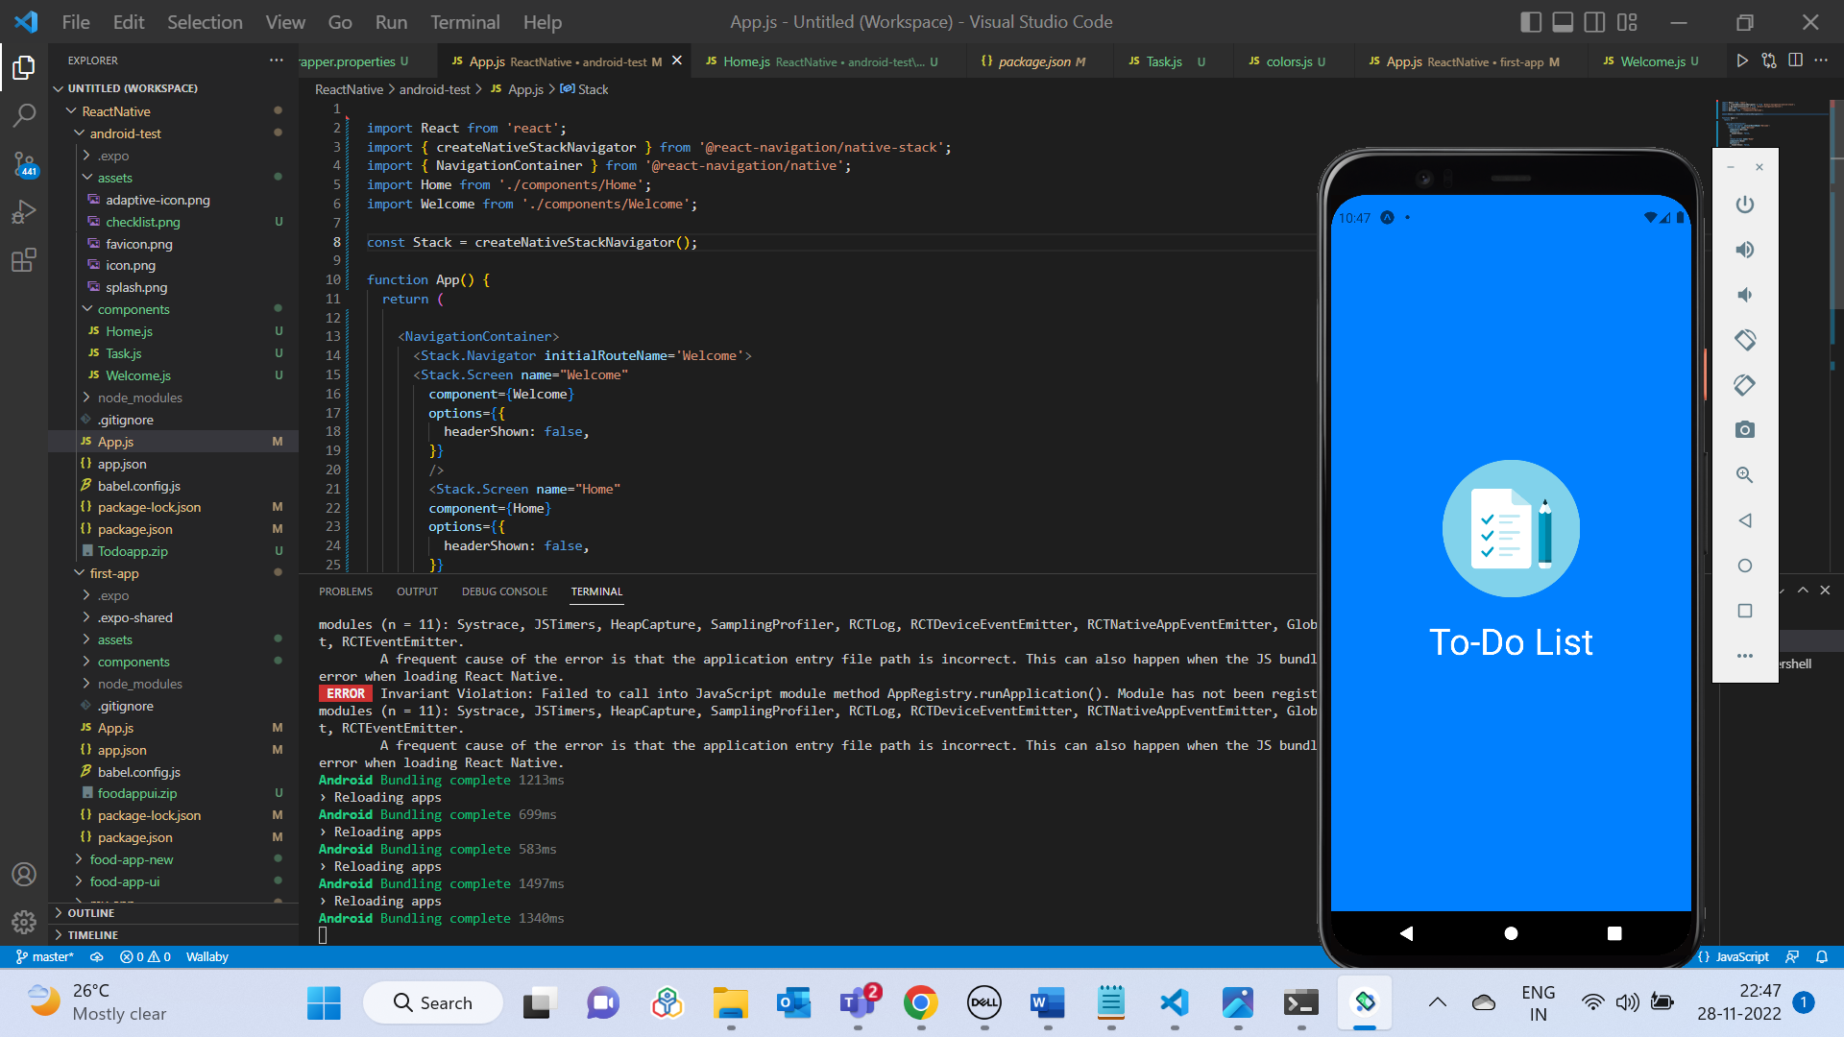

After 5 seconds screen navigates from Welcome page to Home page:

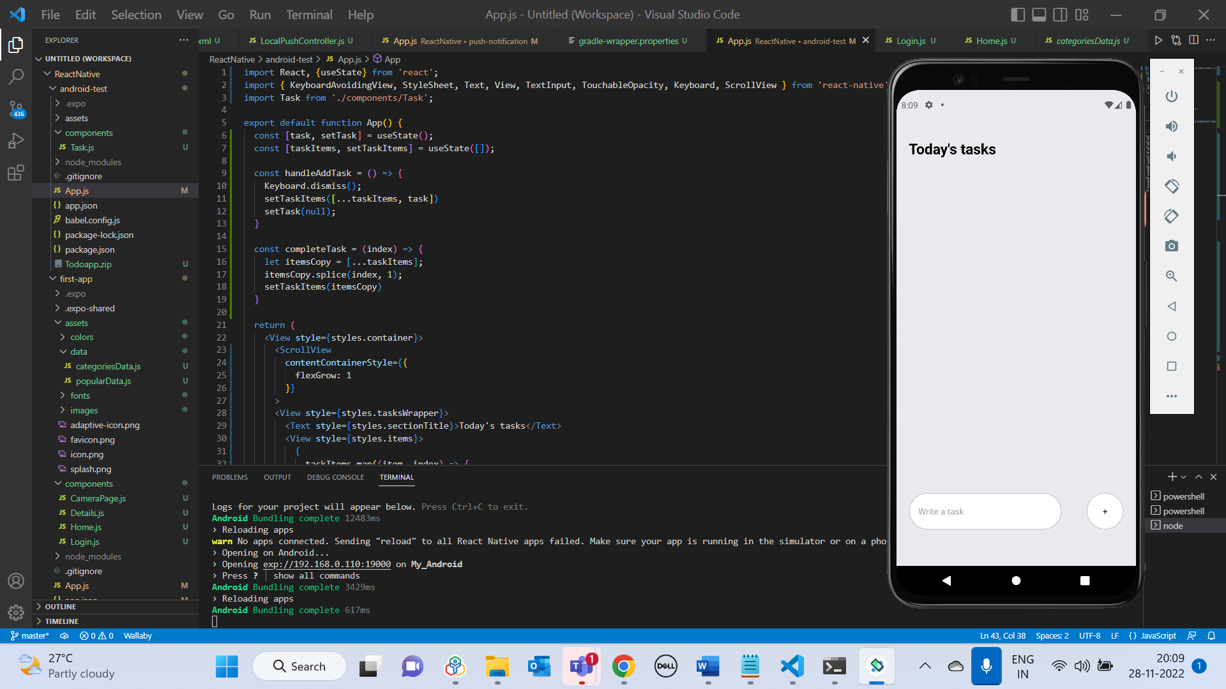

Adding a Task:

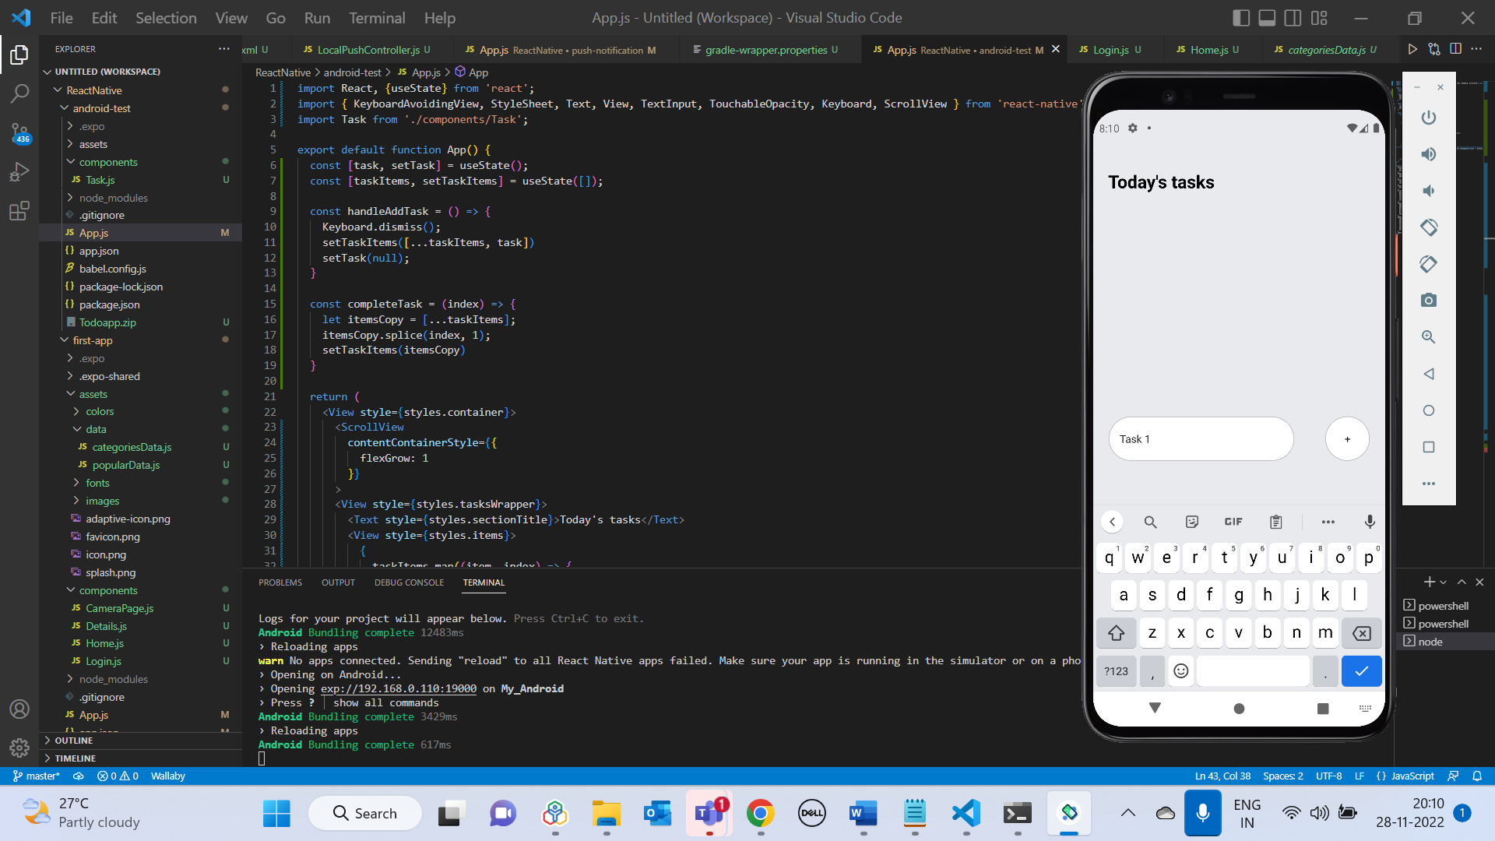

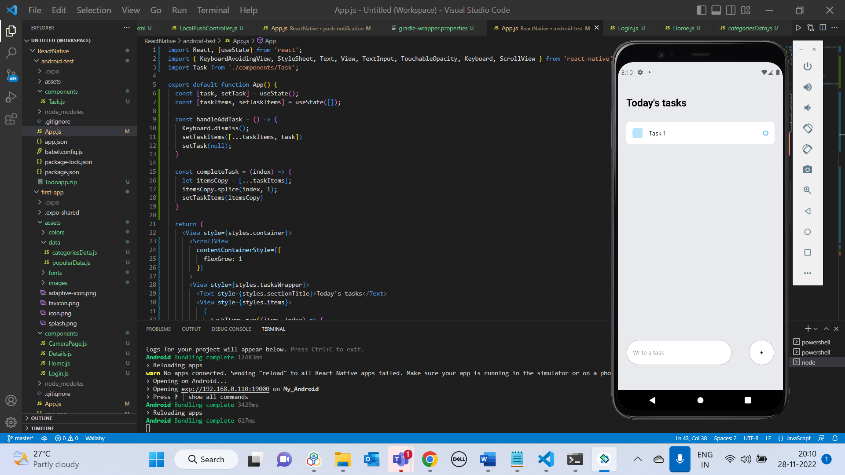

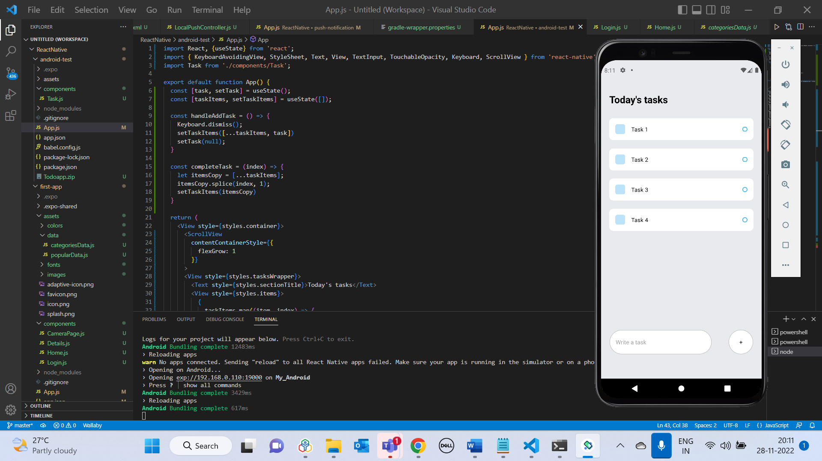

Clicking on the Task deletes the particular task – Task 2 deleted:

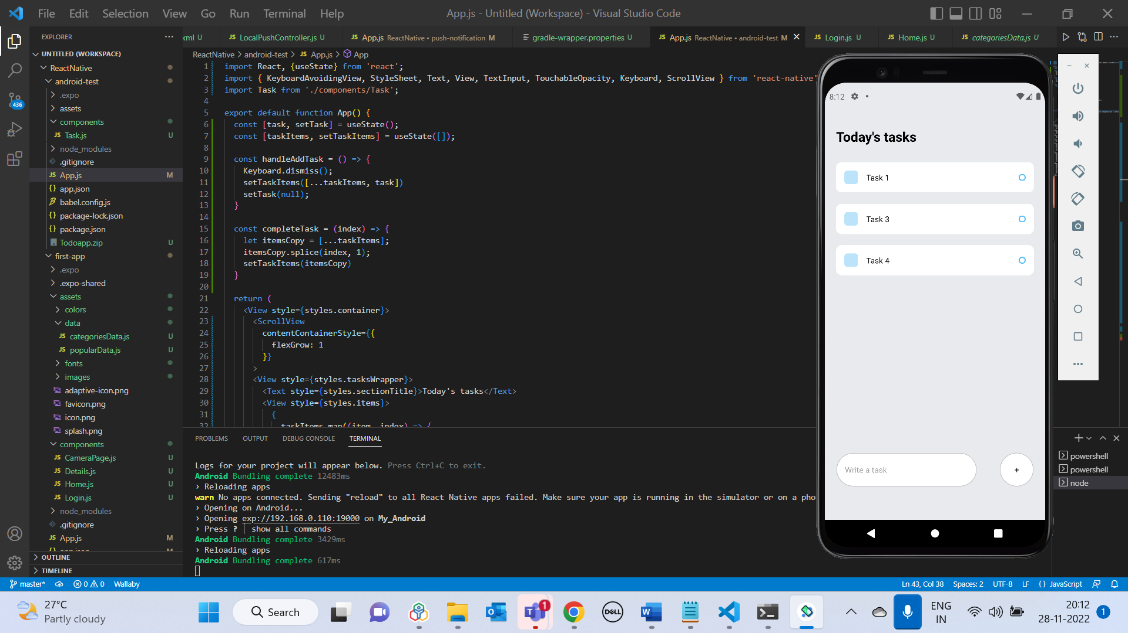

**Sample Food App UI output:­**

Login screen:

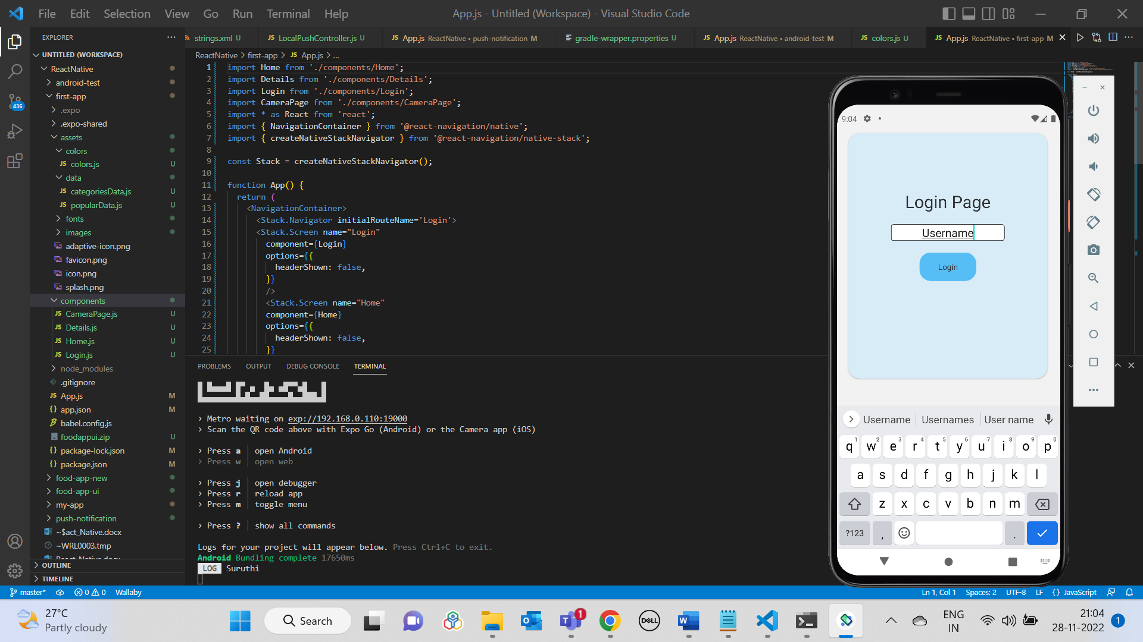

Home Screen:

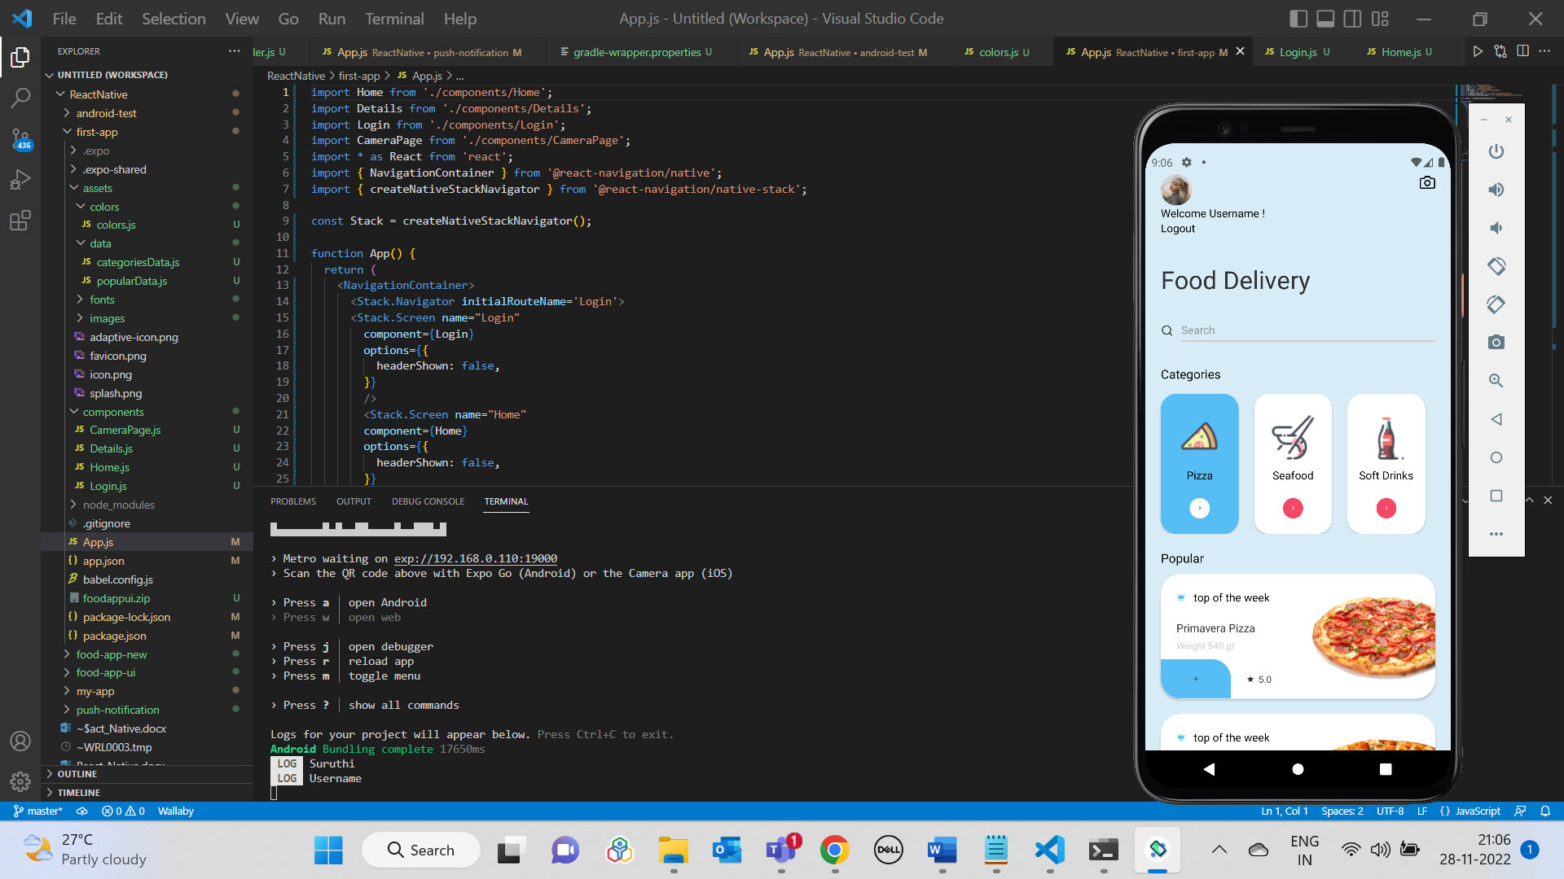

Clicking on an item in Popular list (Logs item details and navigates to Item’s details page):

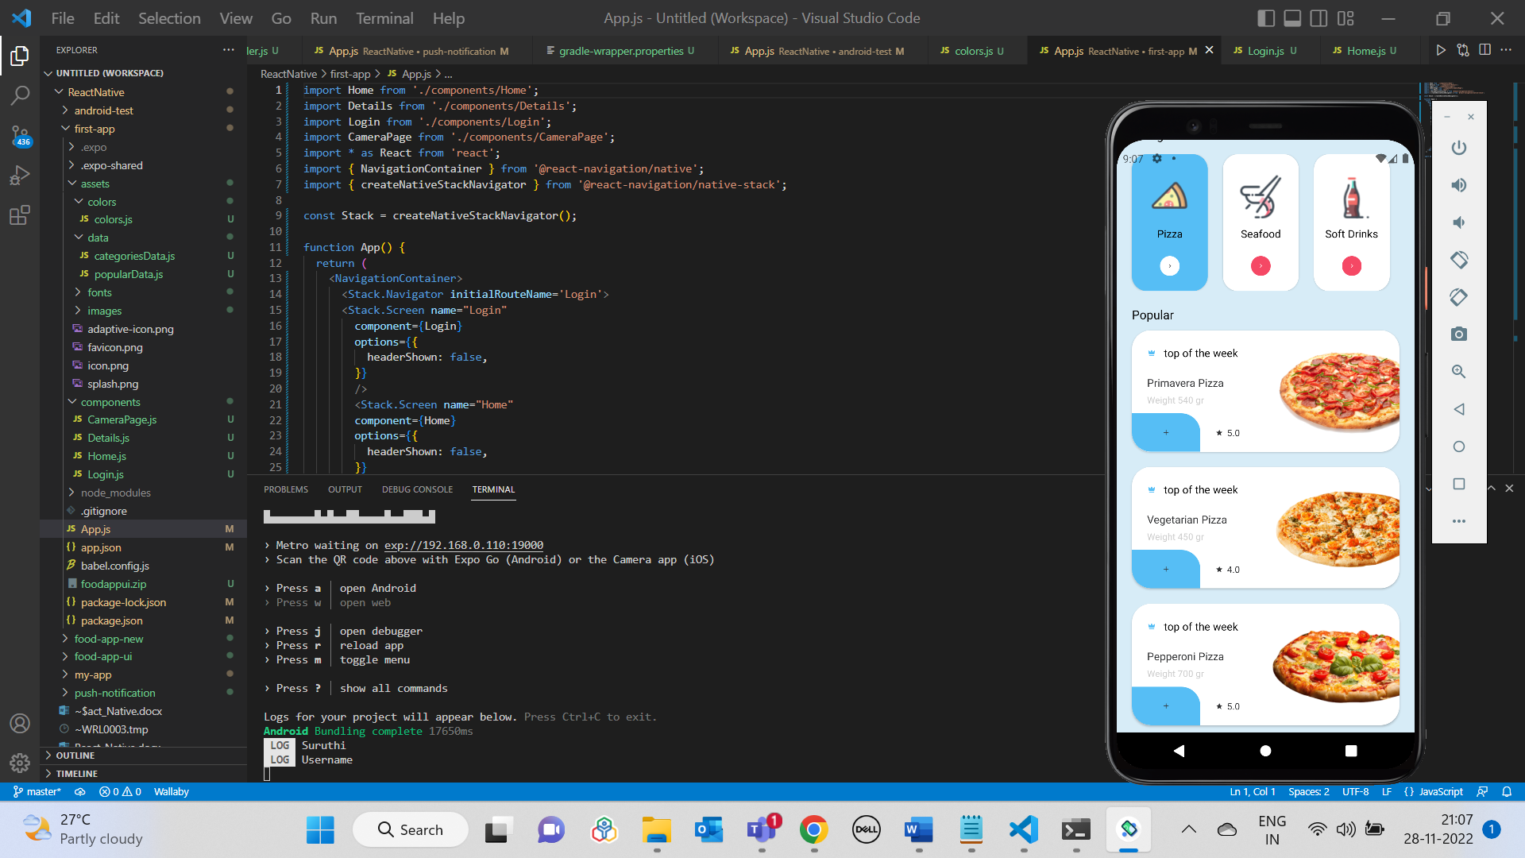

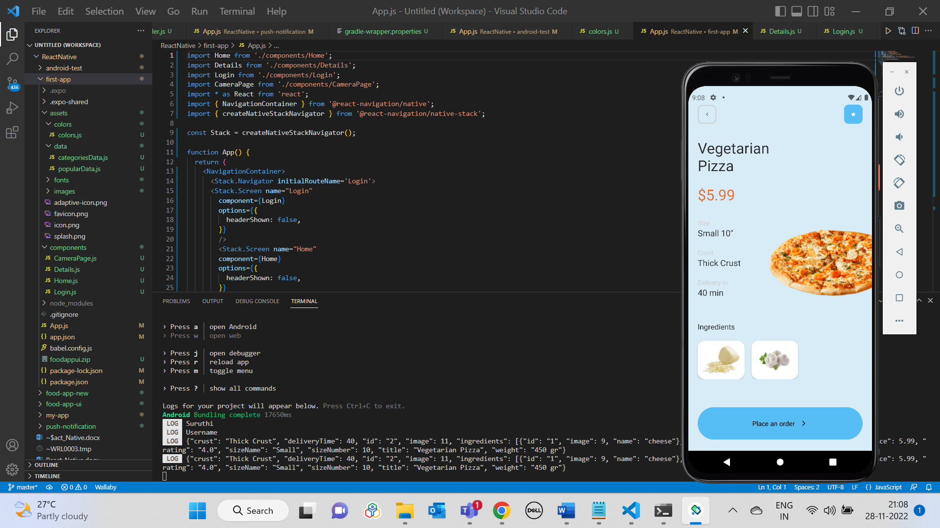

Clicking on Place an Order button:

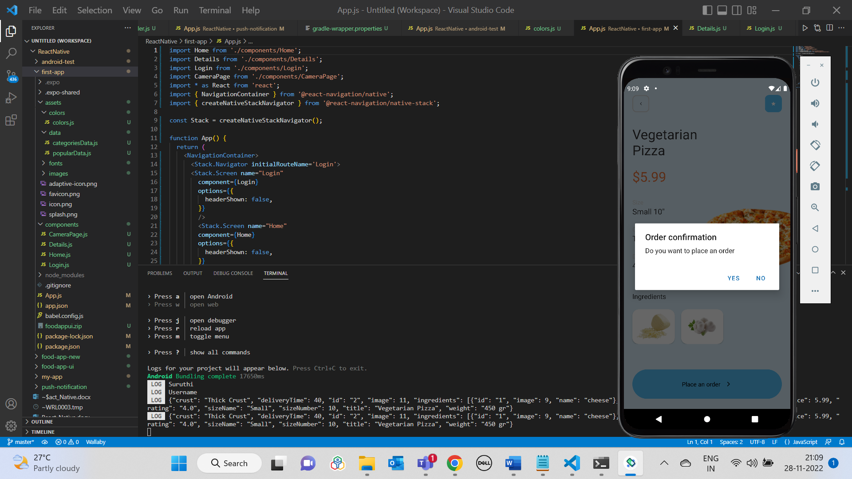

Clicking on Yes (Logs “Order placed”):

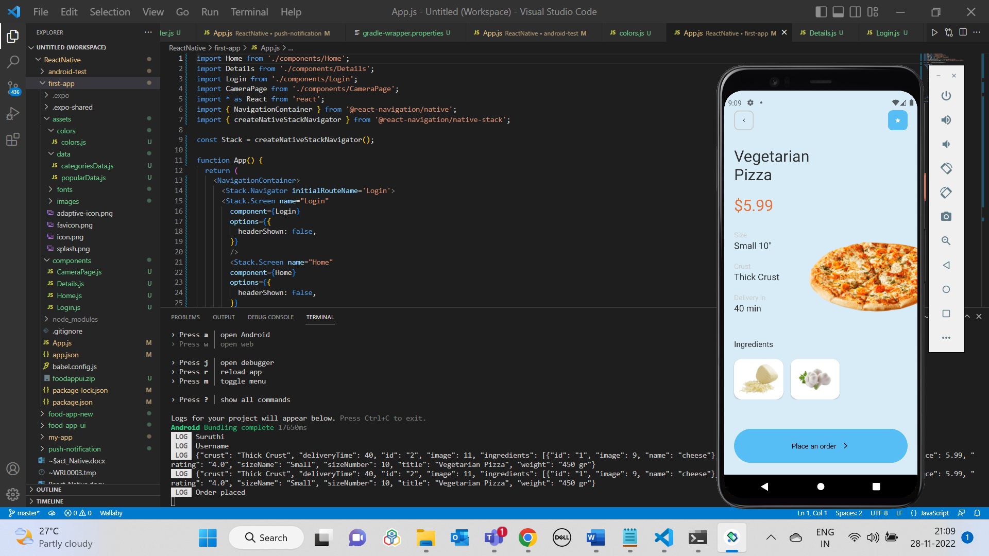

Camera button in Home screen:

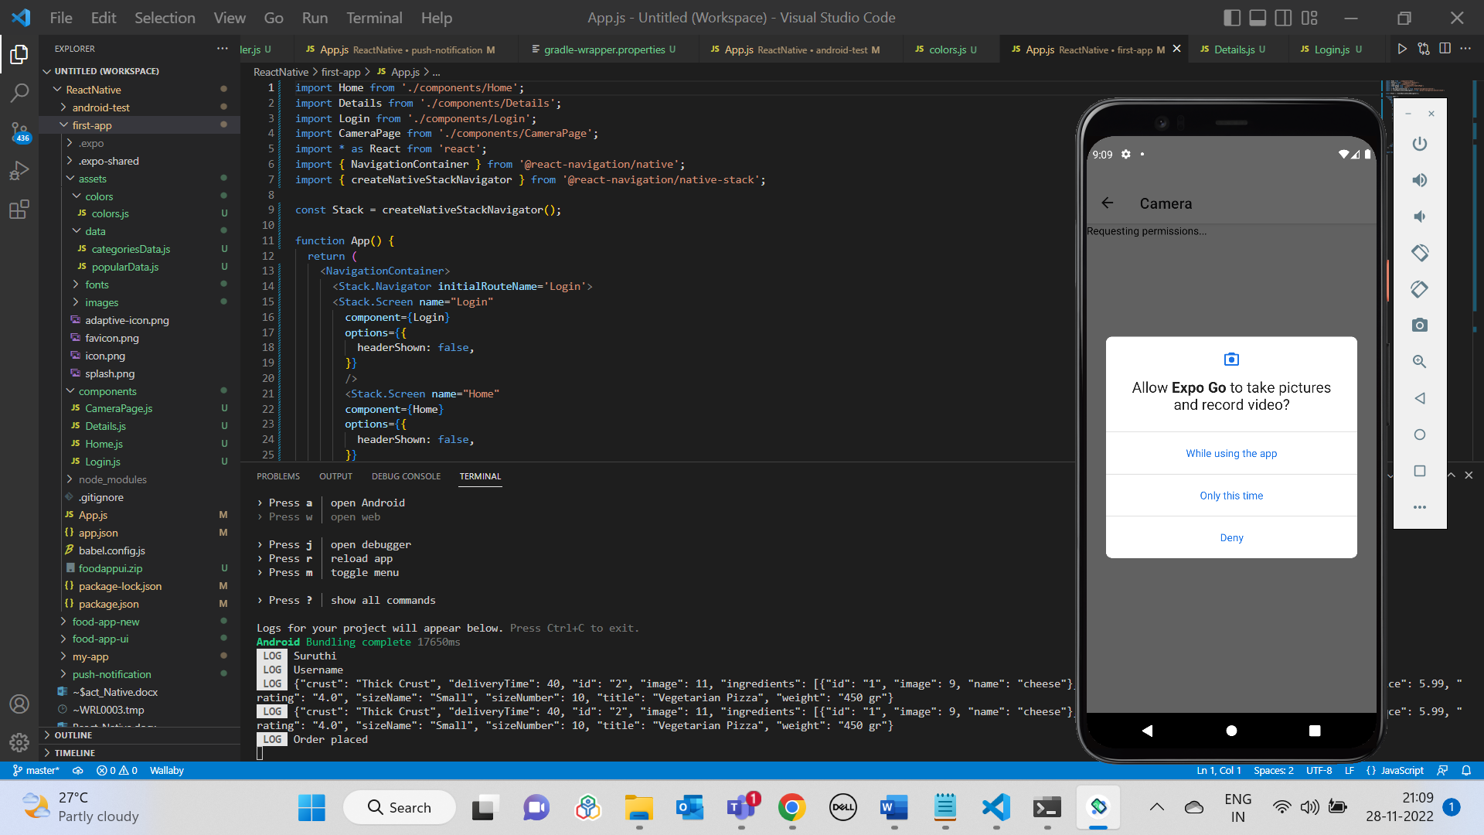

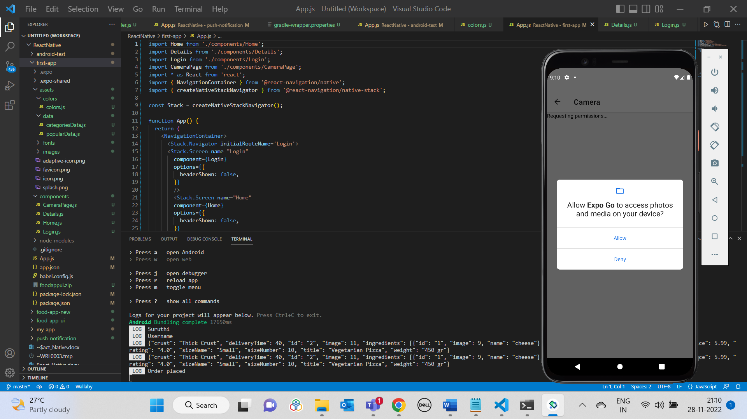

Clicking on Take Picture button:

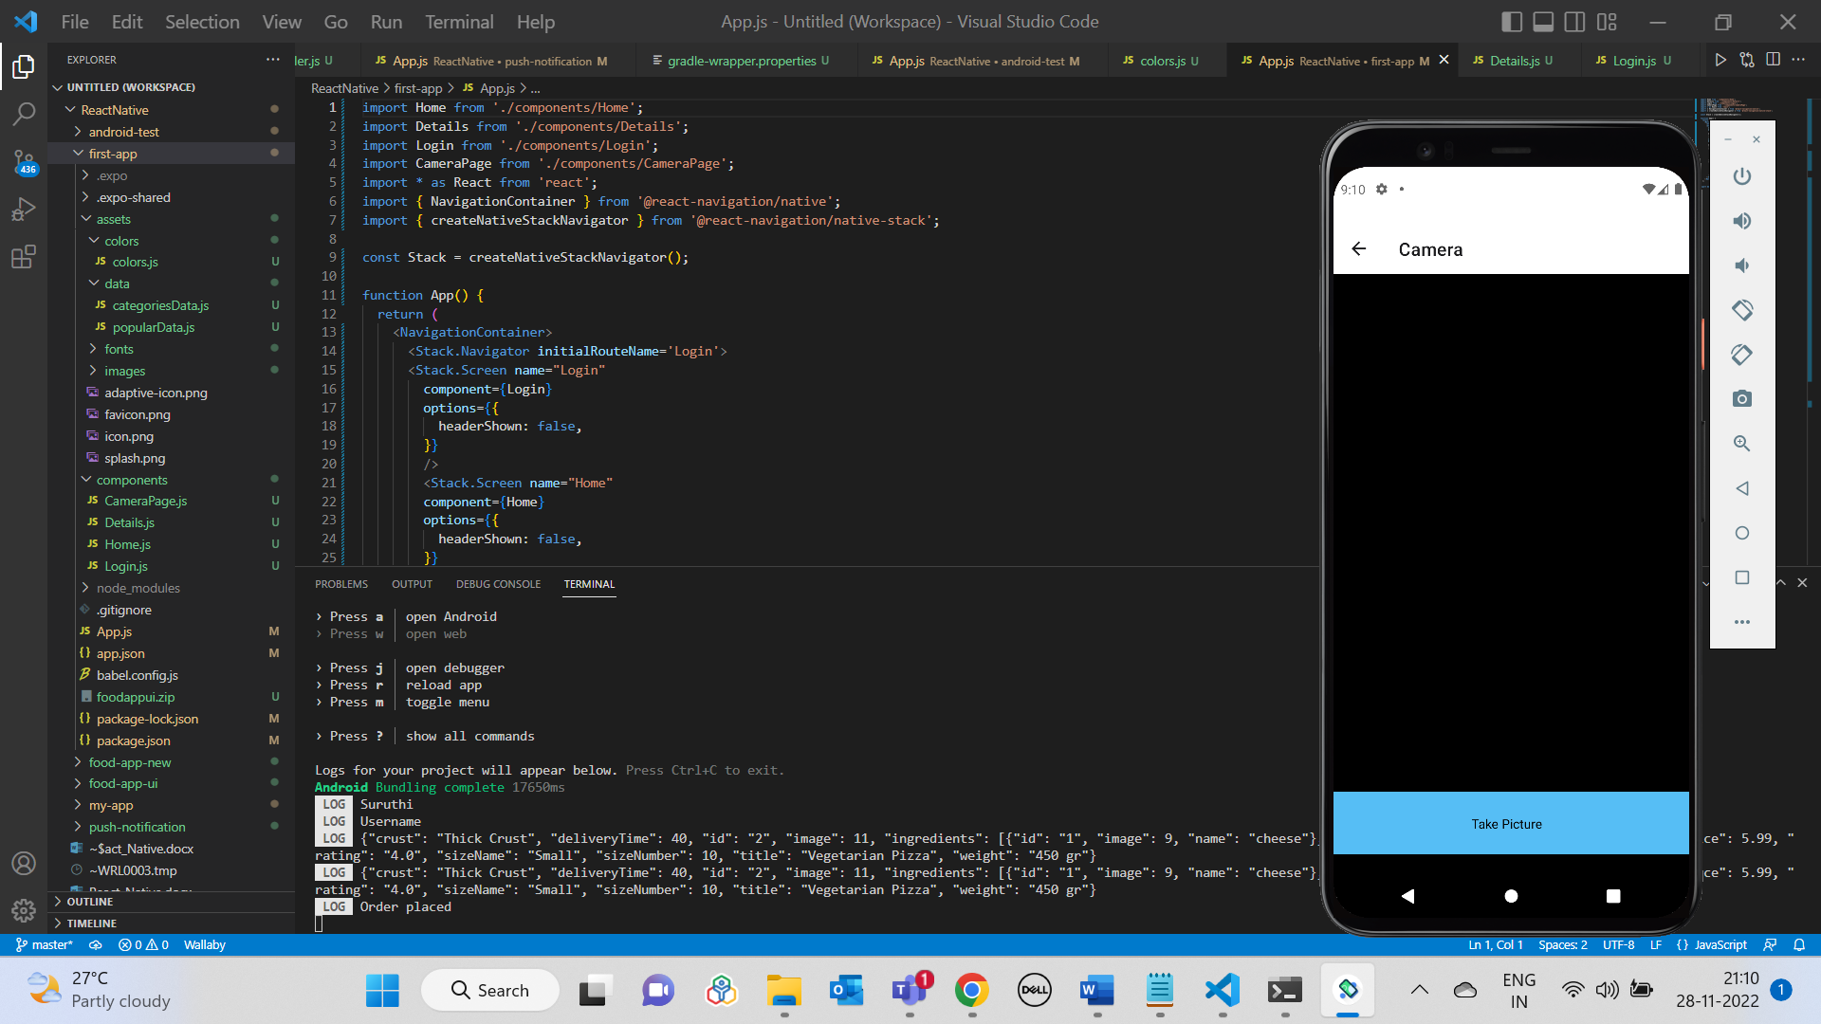

Preview page:

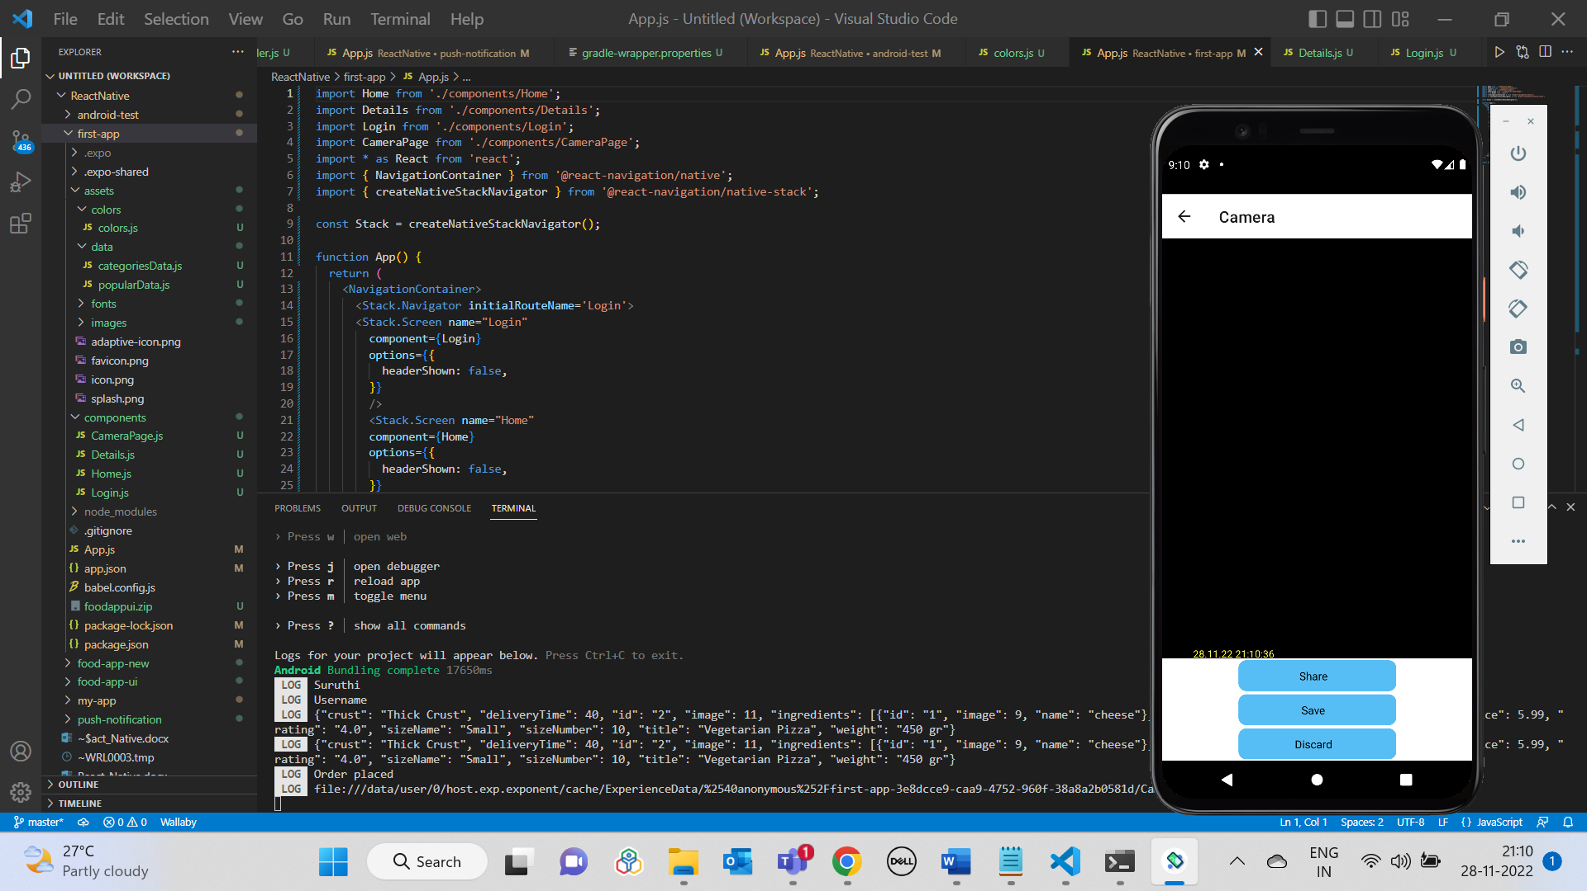

Clicking on Save button in Preview page:

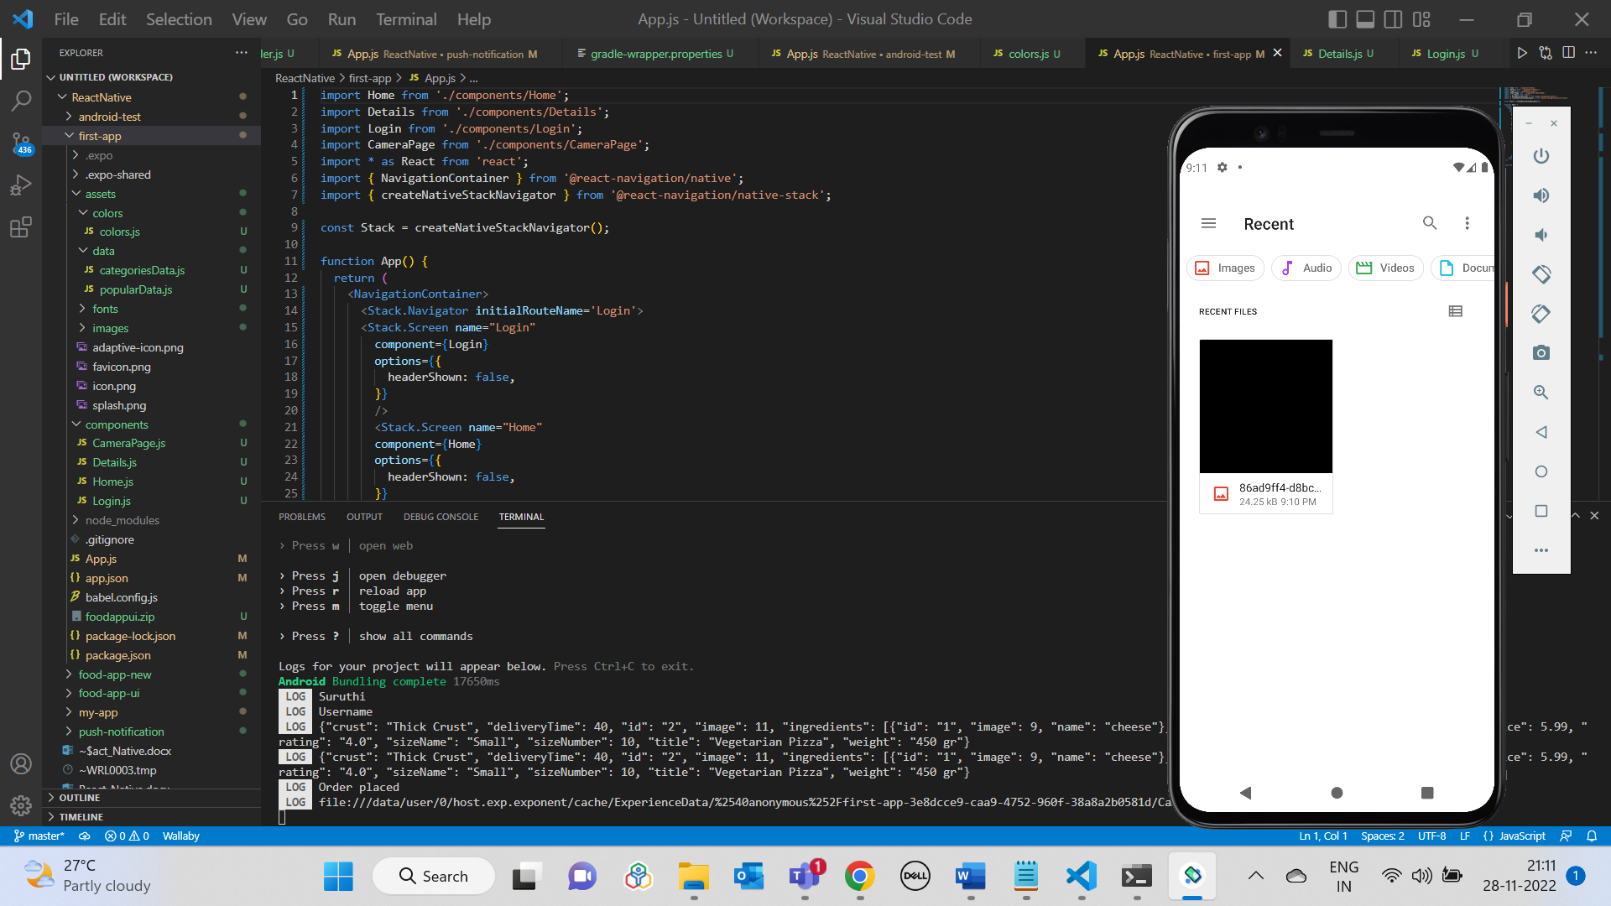

Clicking on Share button:

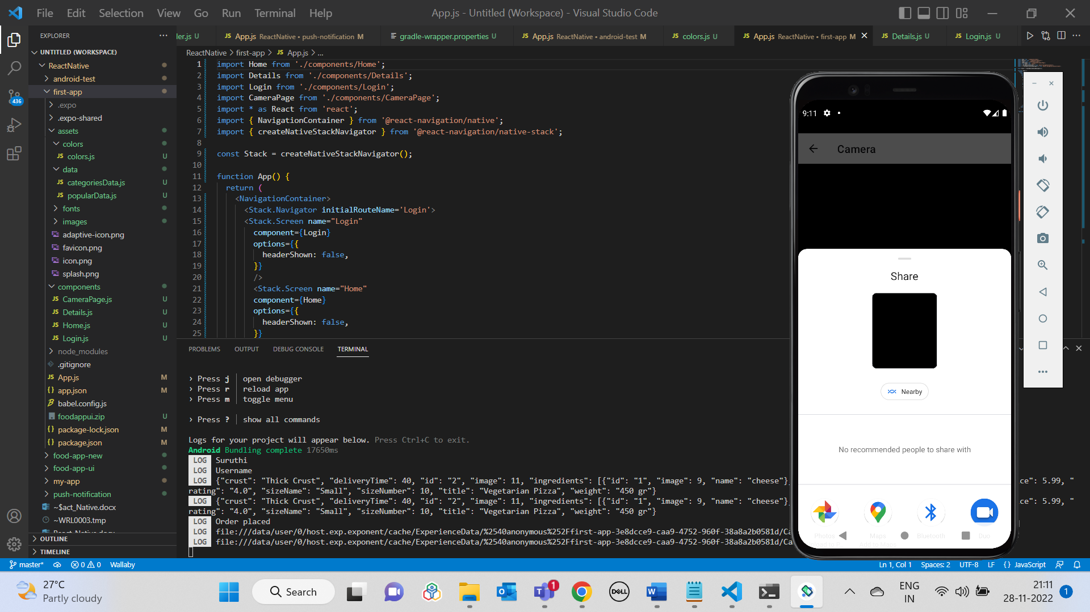

Clicking on Discard button:

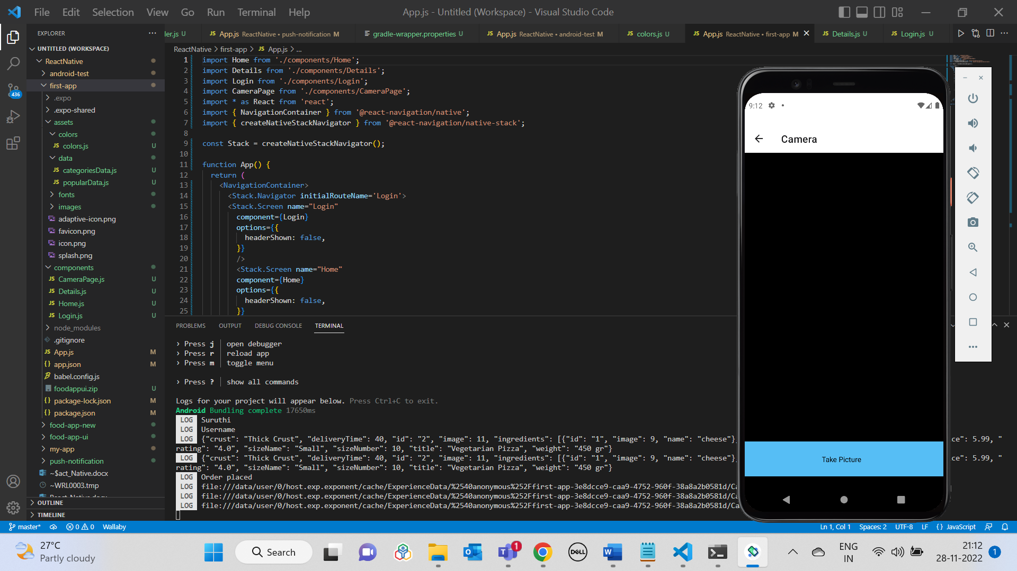

**Quiz App UI Output**

|  |  |
| --- | --- |
|  |  |

|  |  |
| --- | --- |
|  |  |

**Twitter Reference App Output**

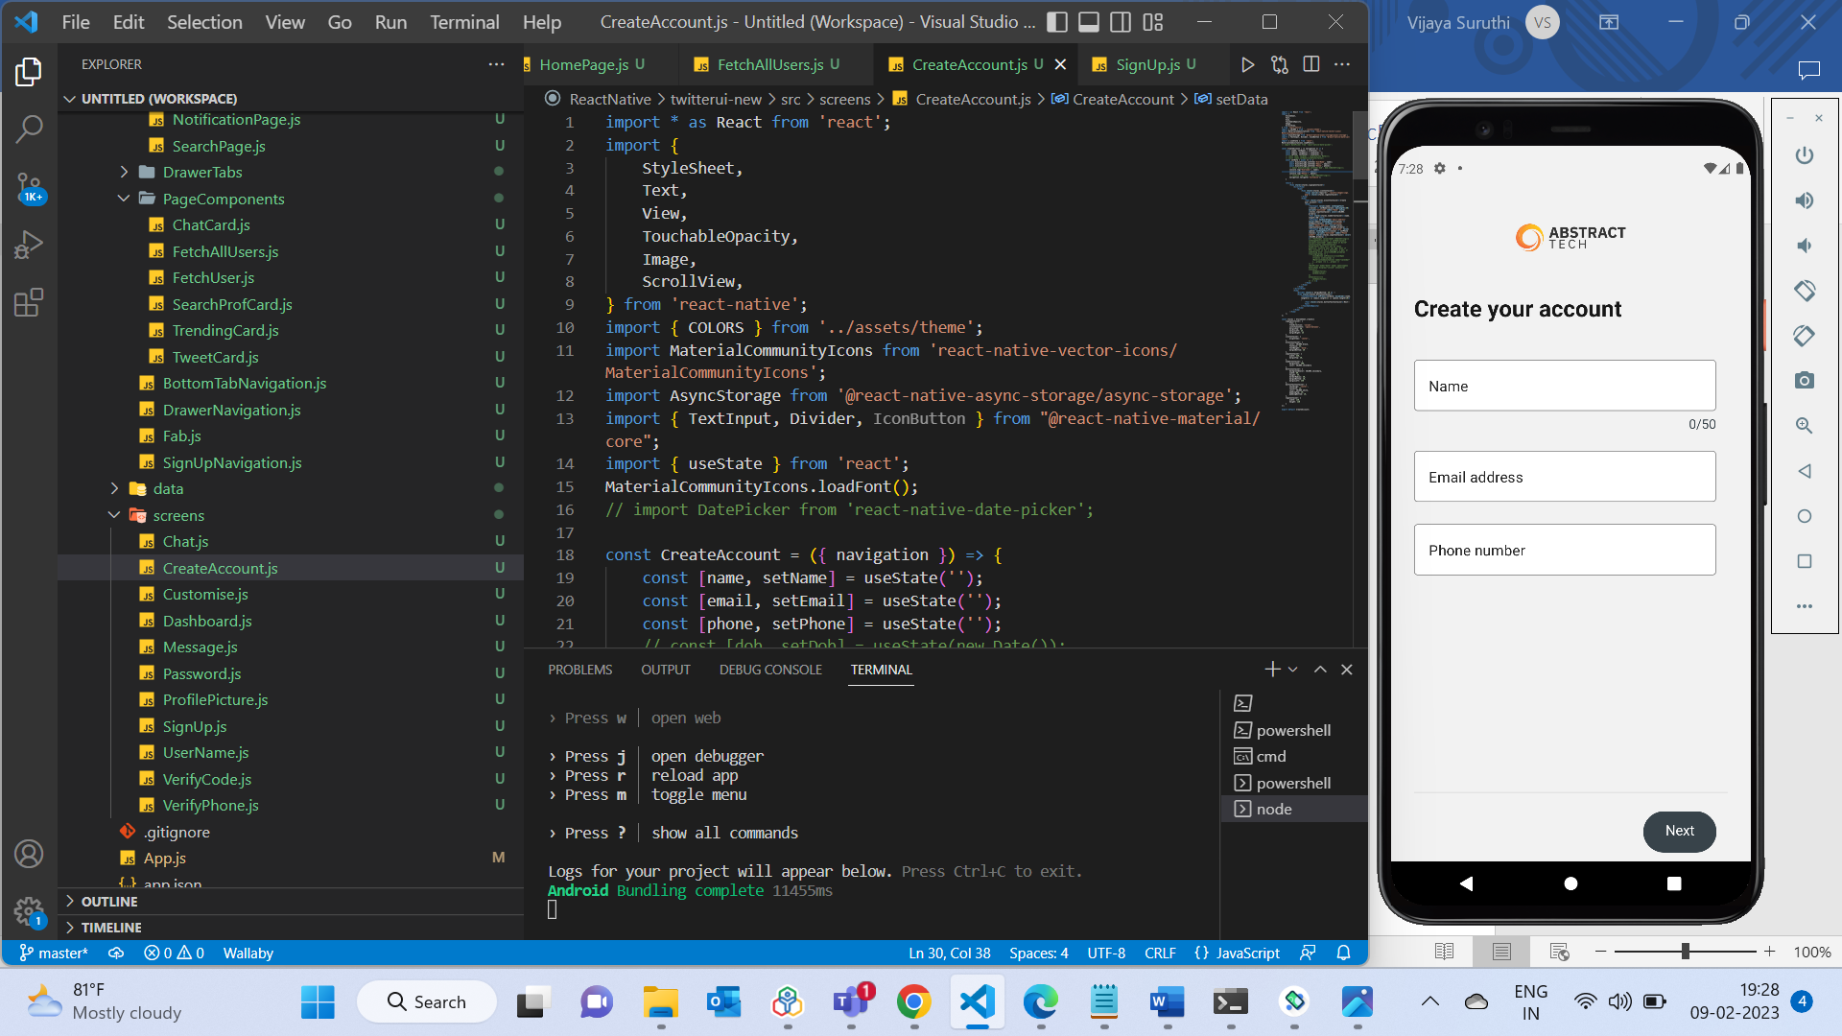

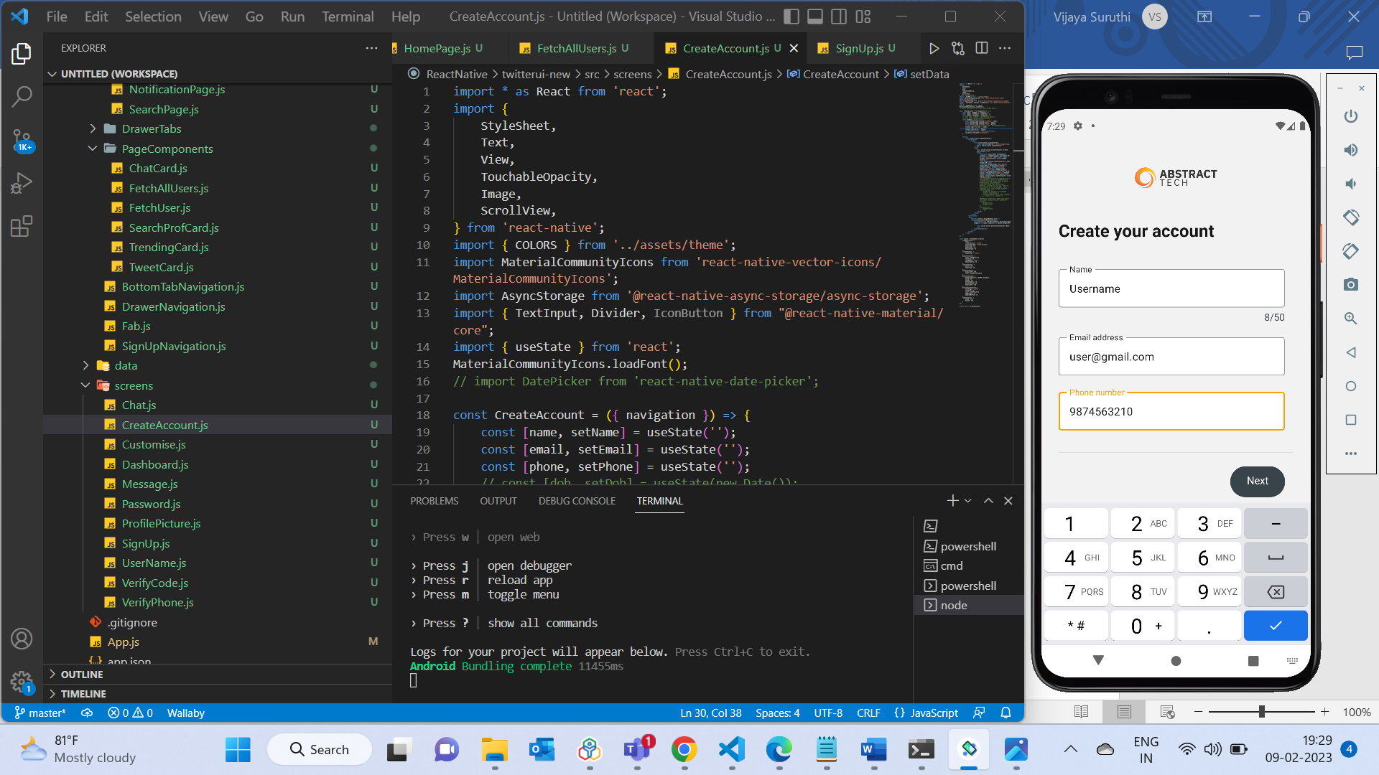

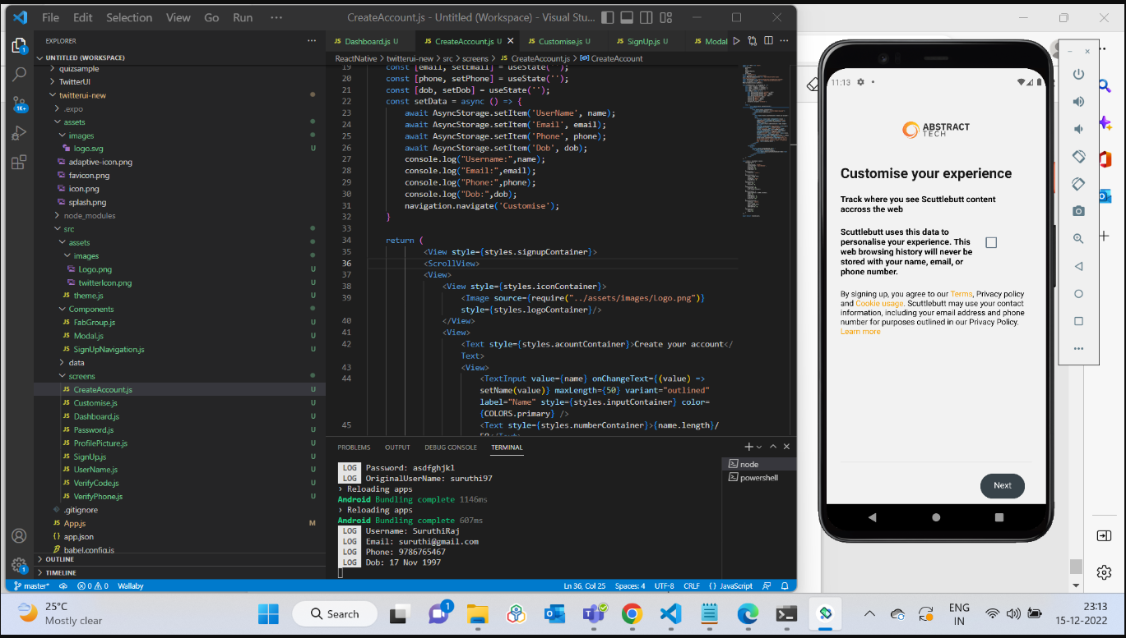

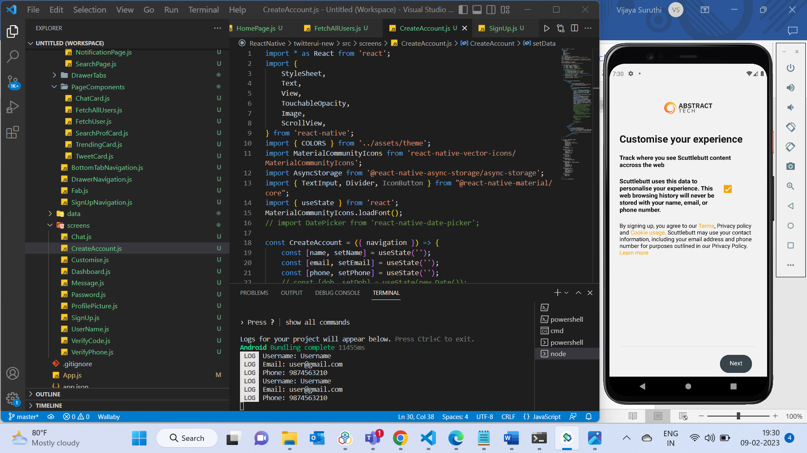

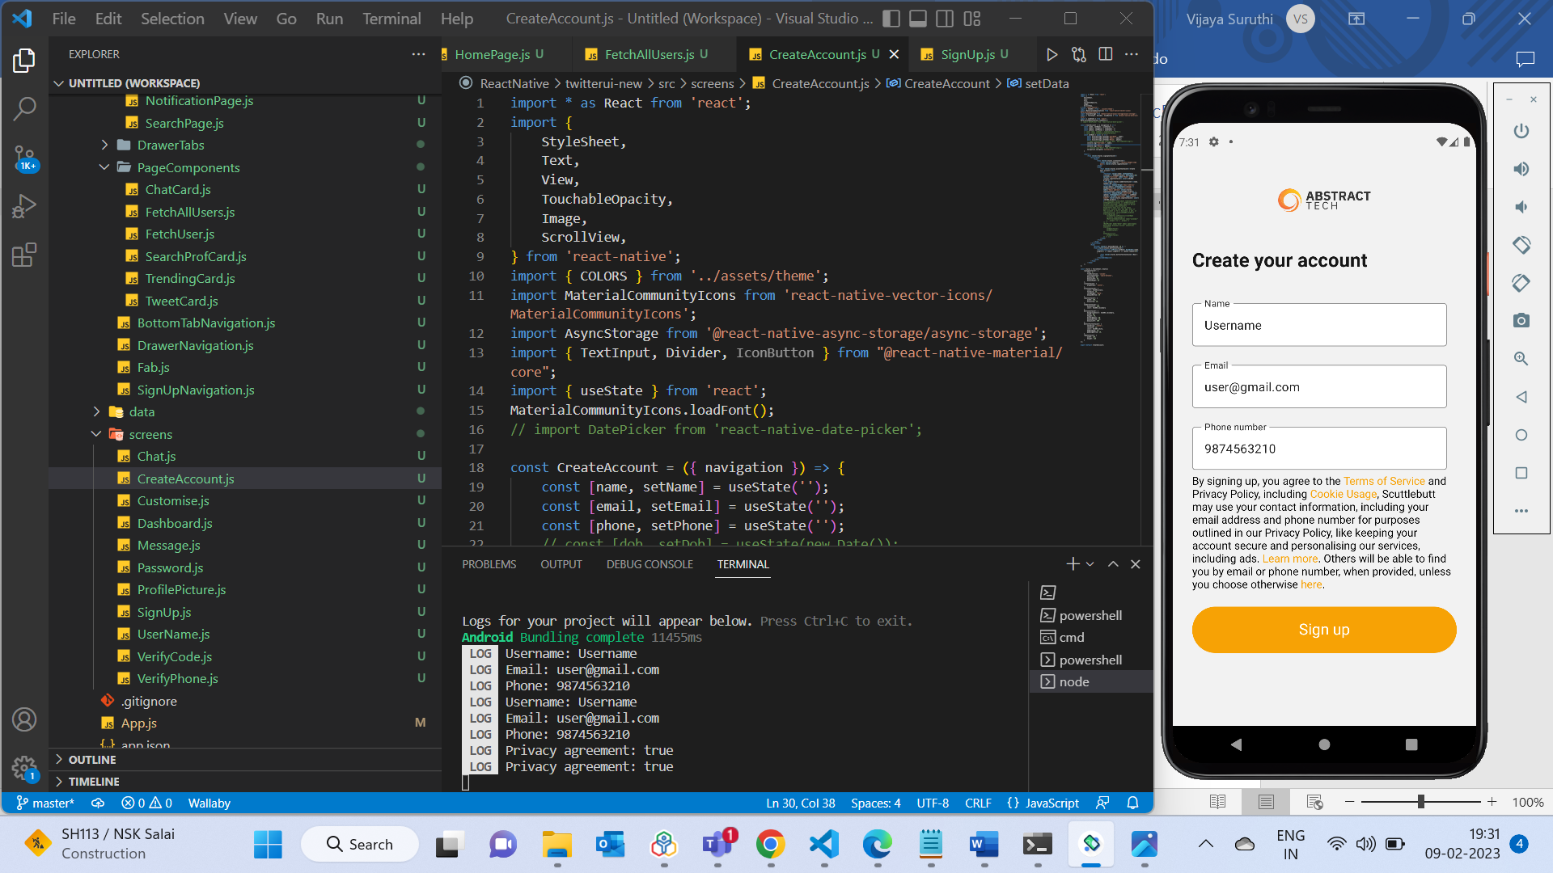

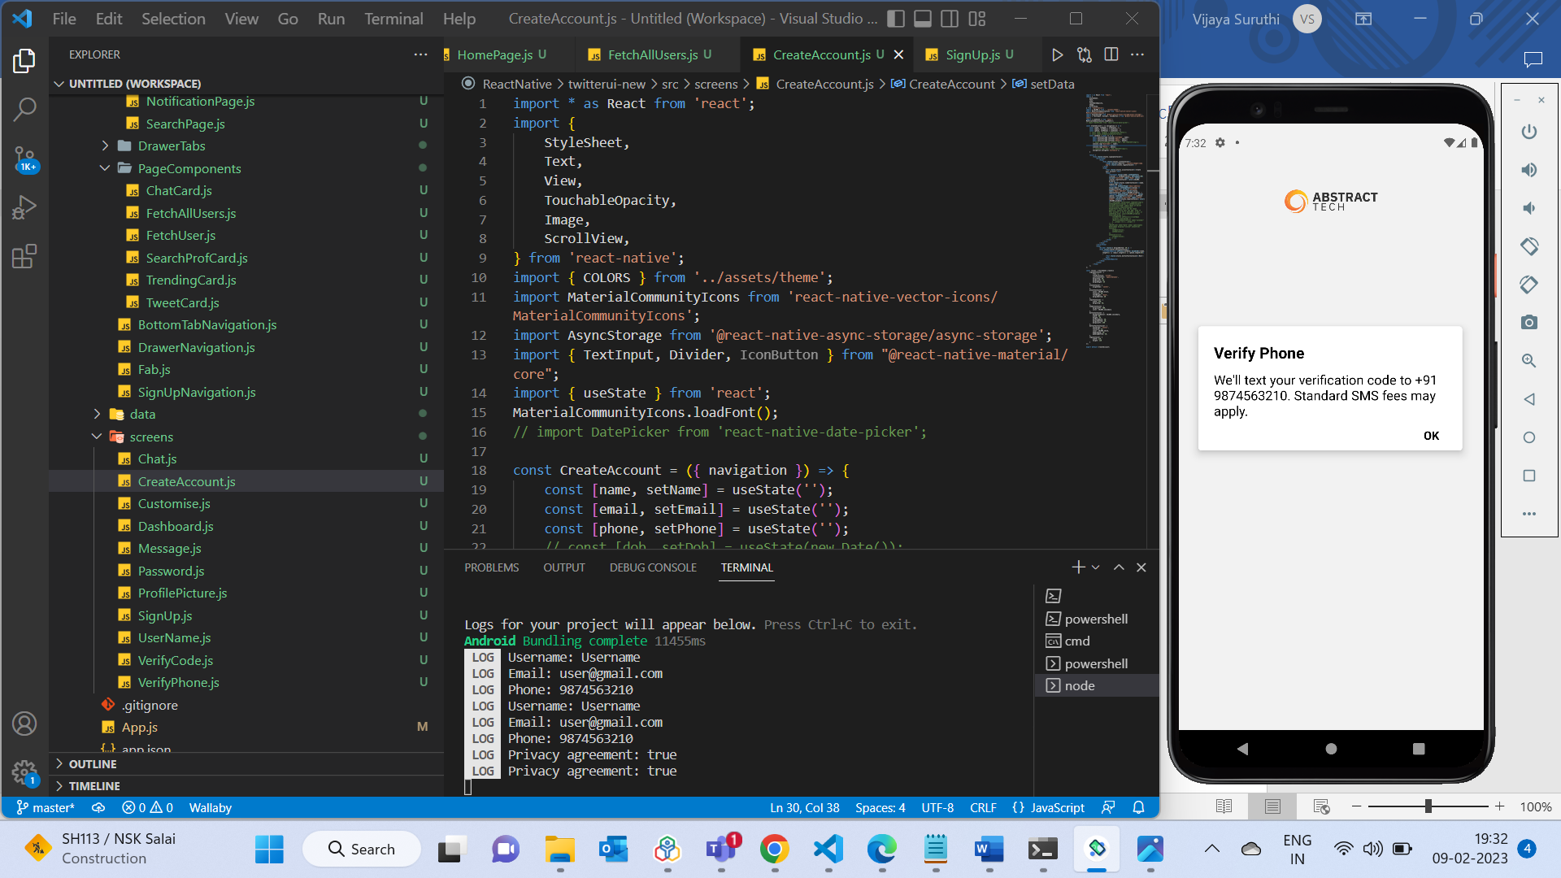

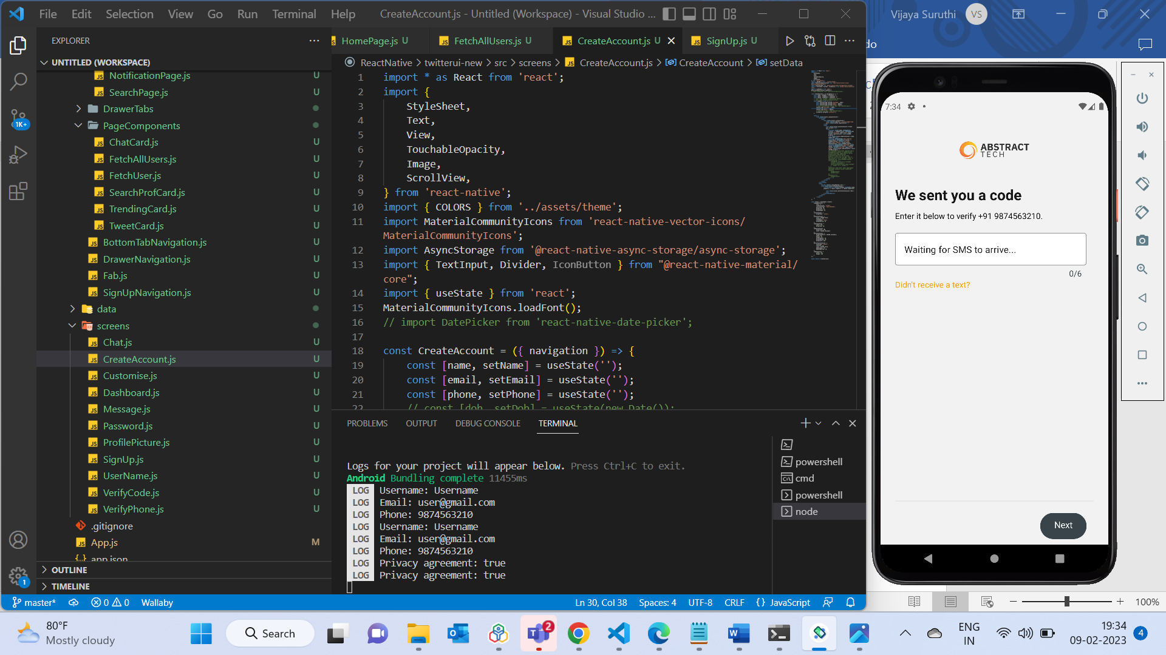

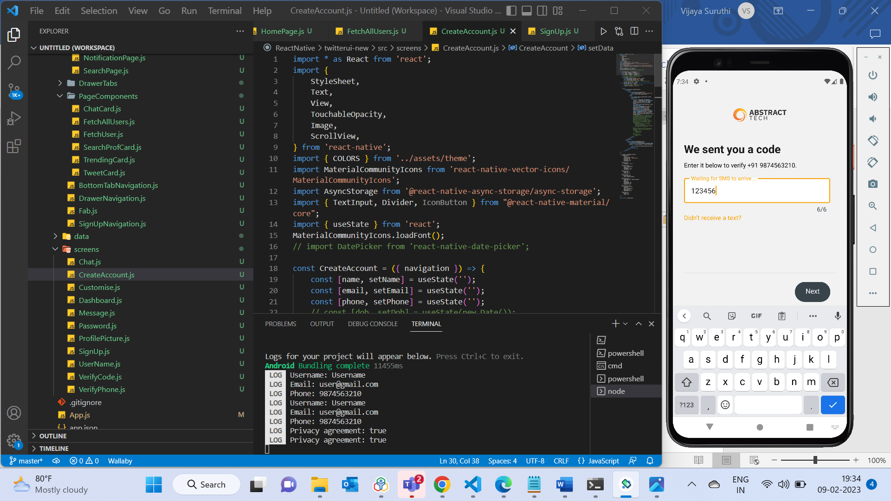

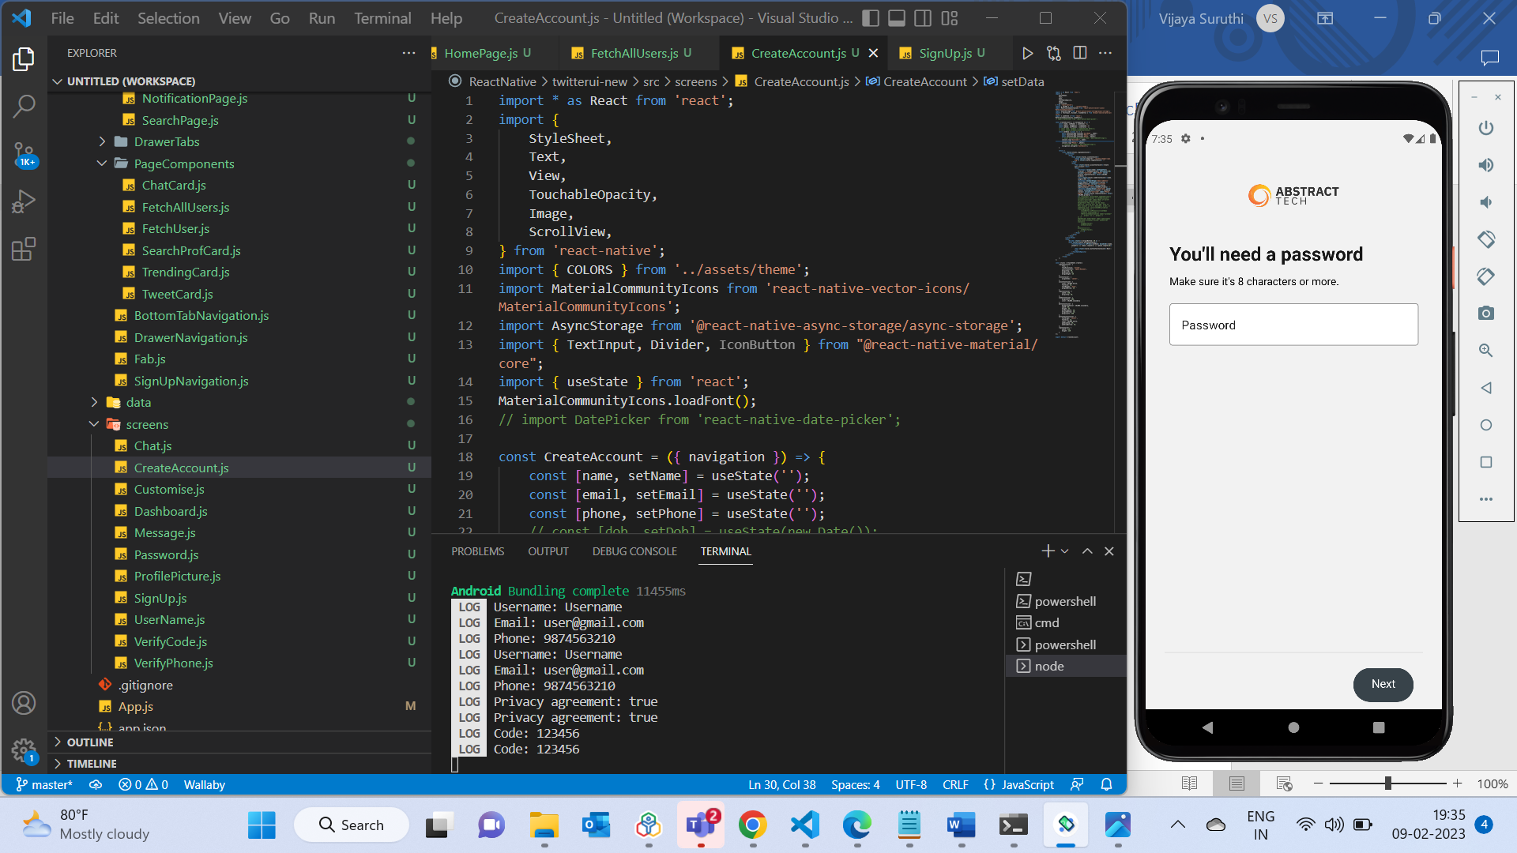

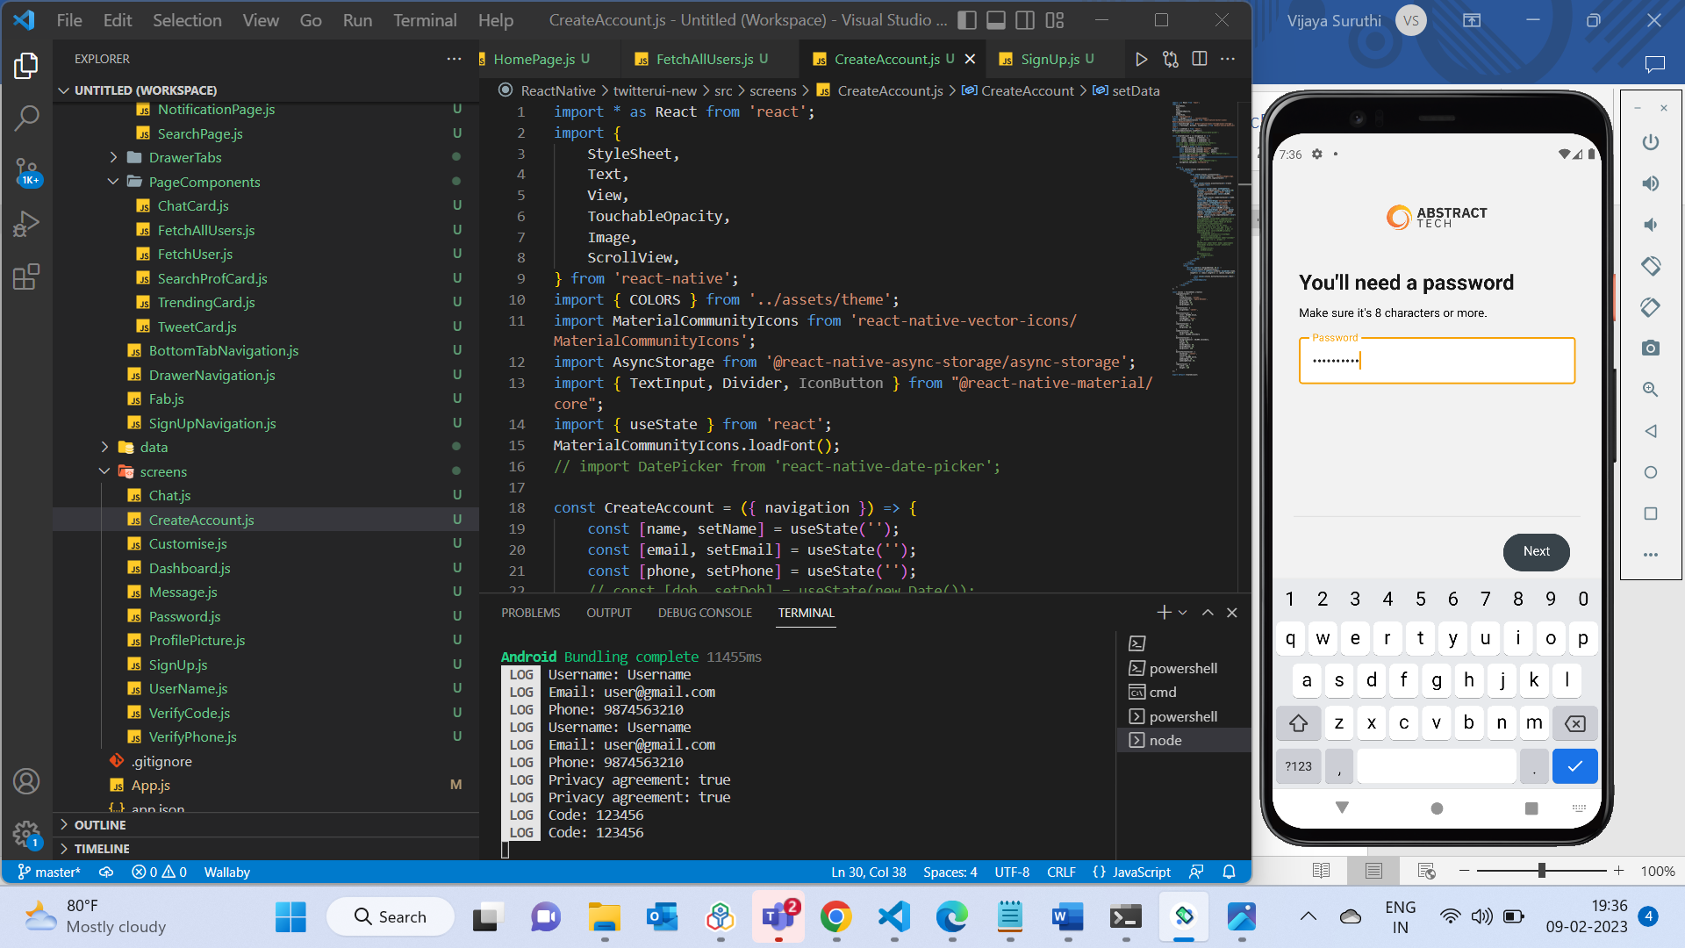

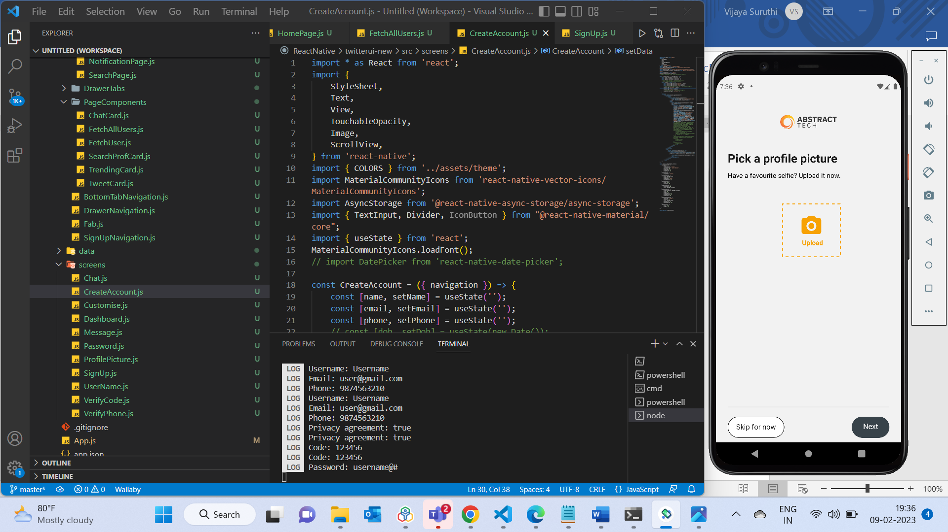

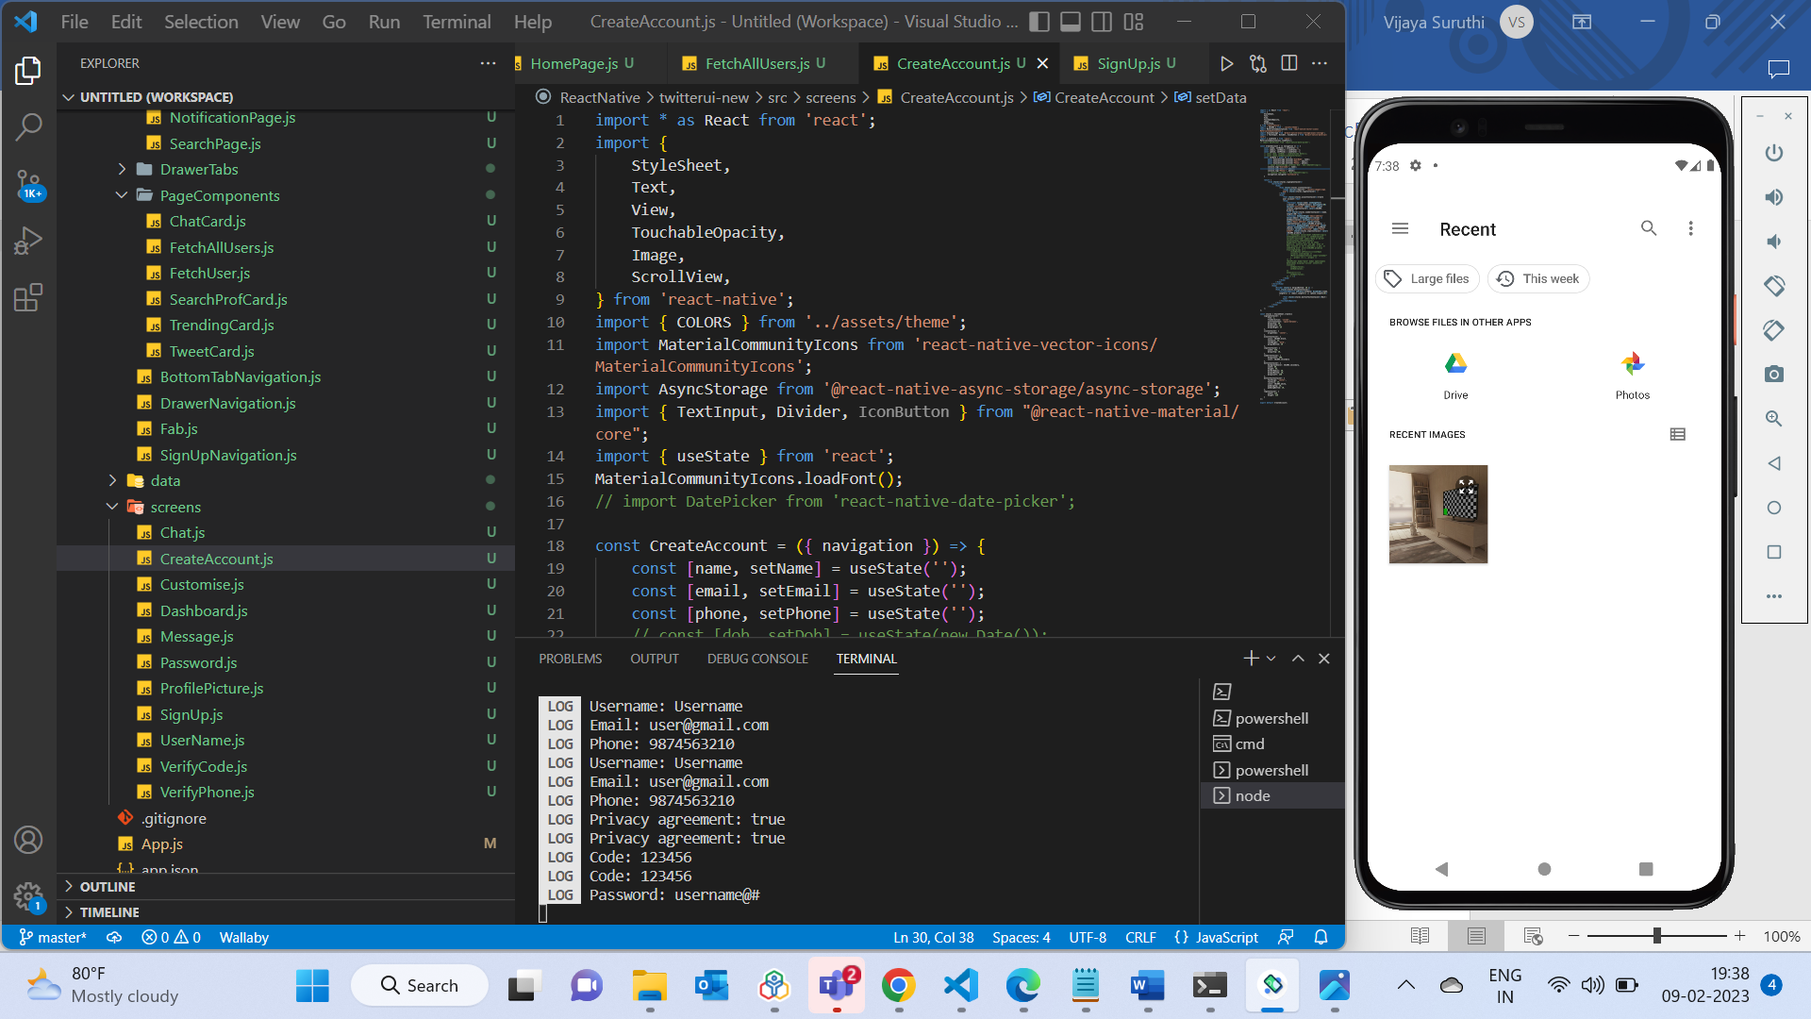

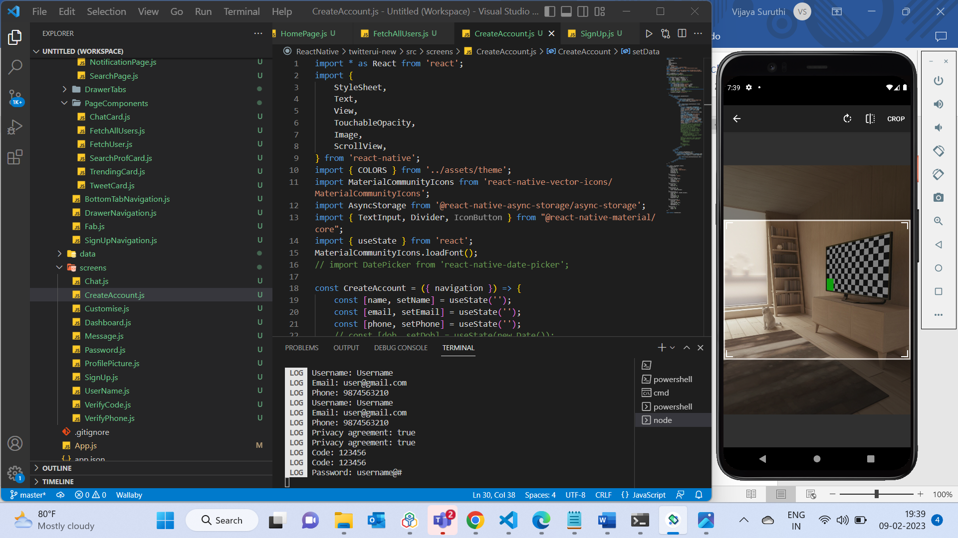

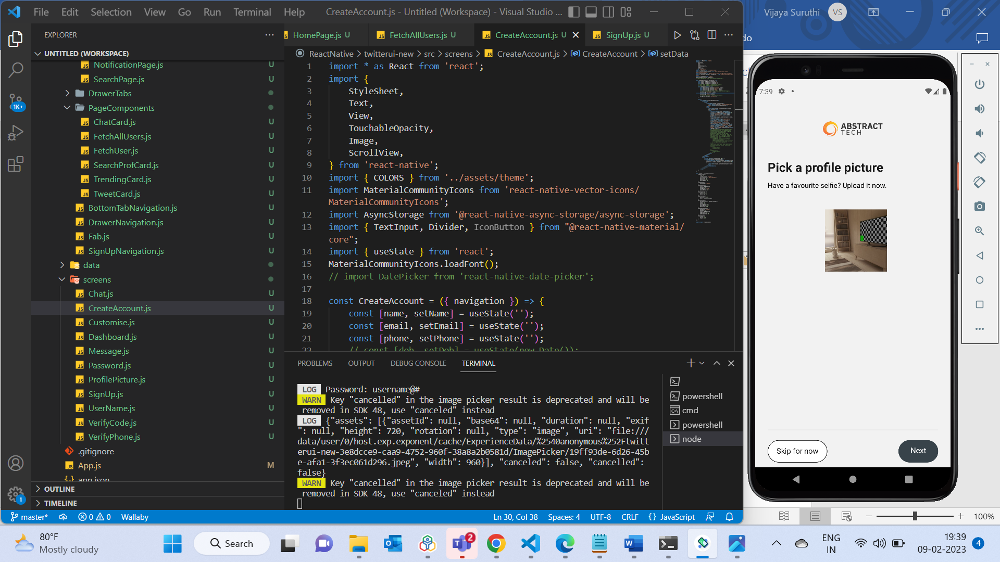

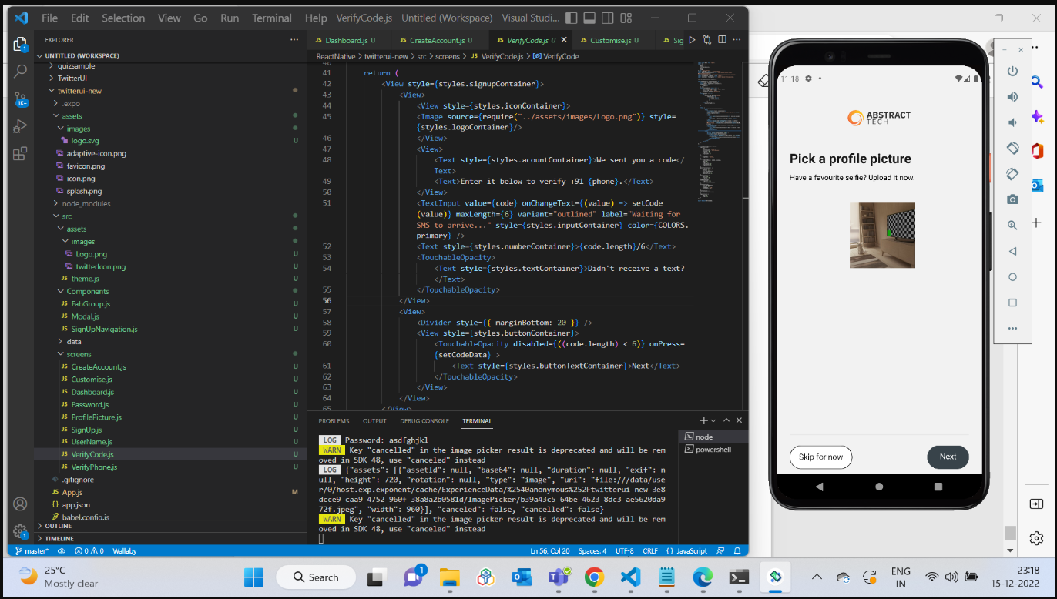

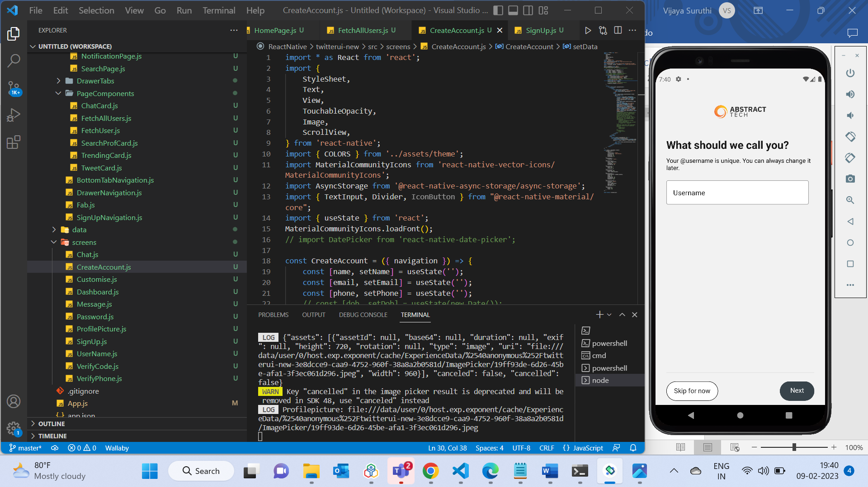

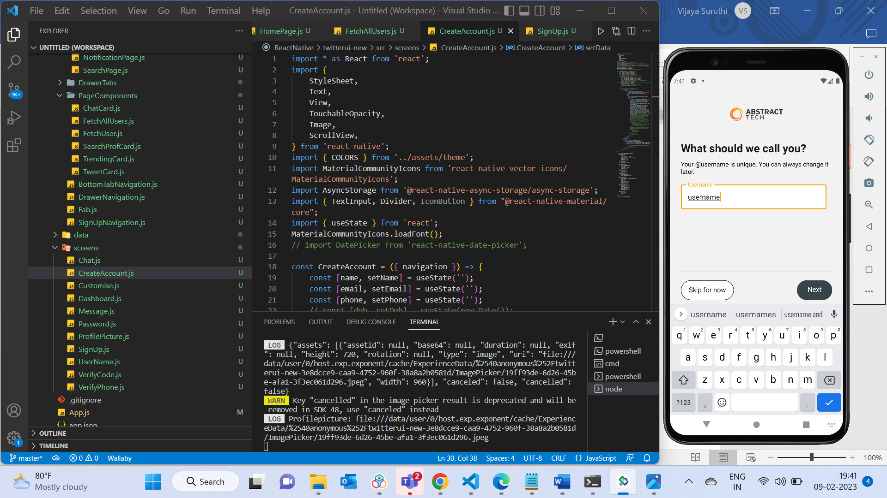

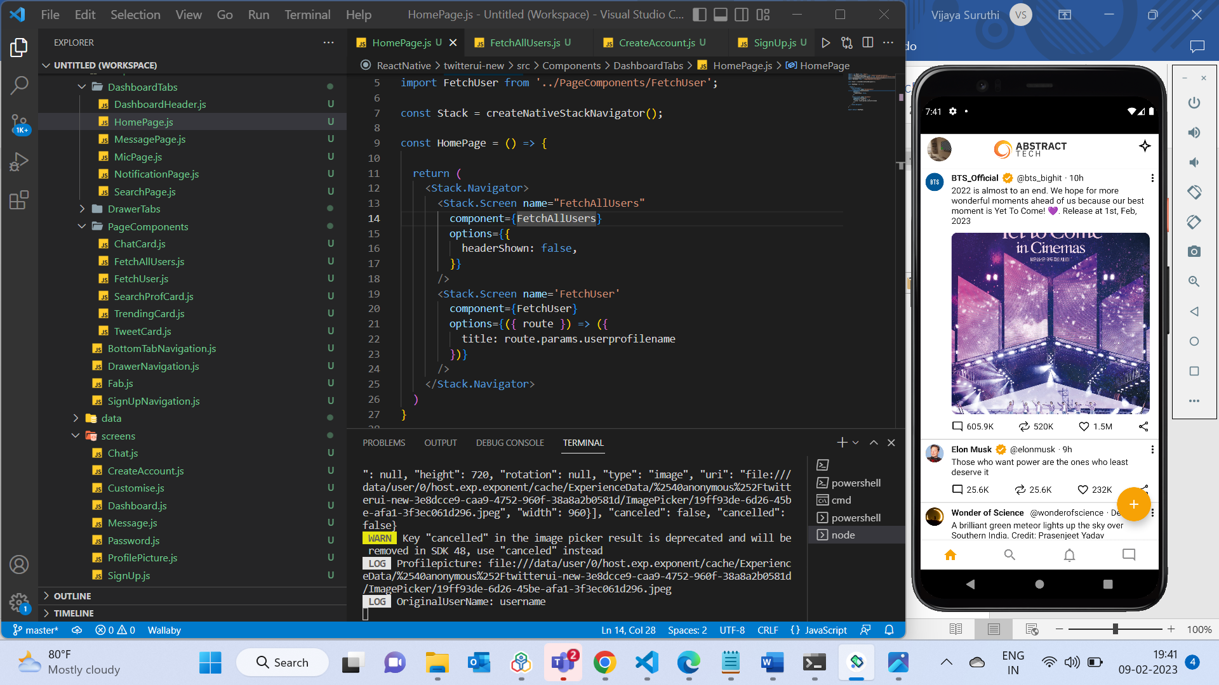

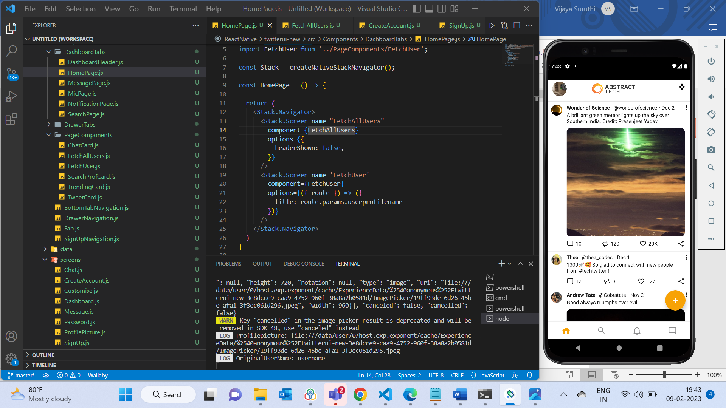

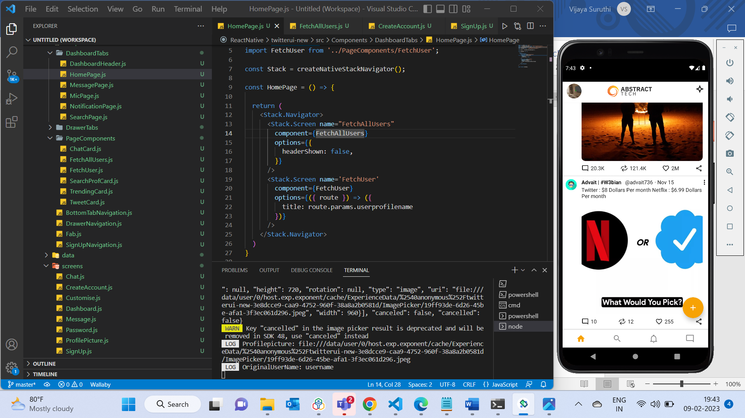

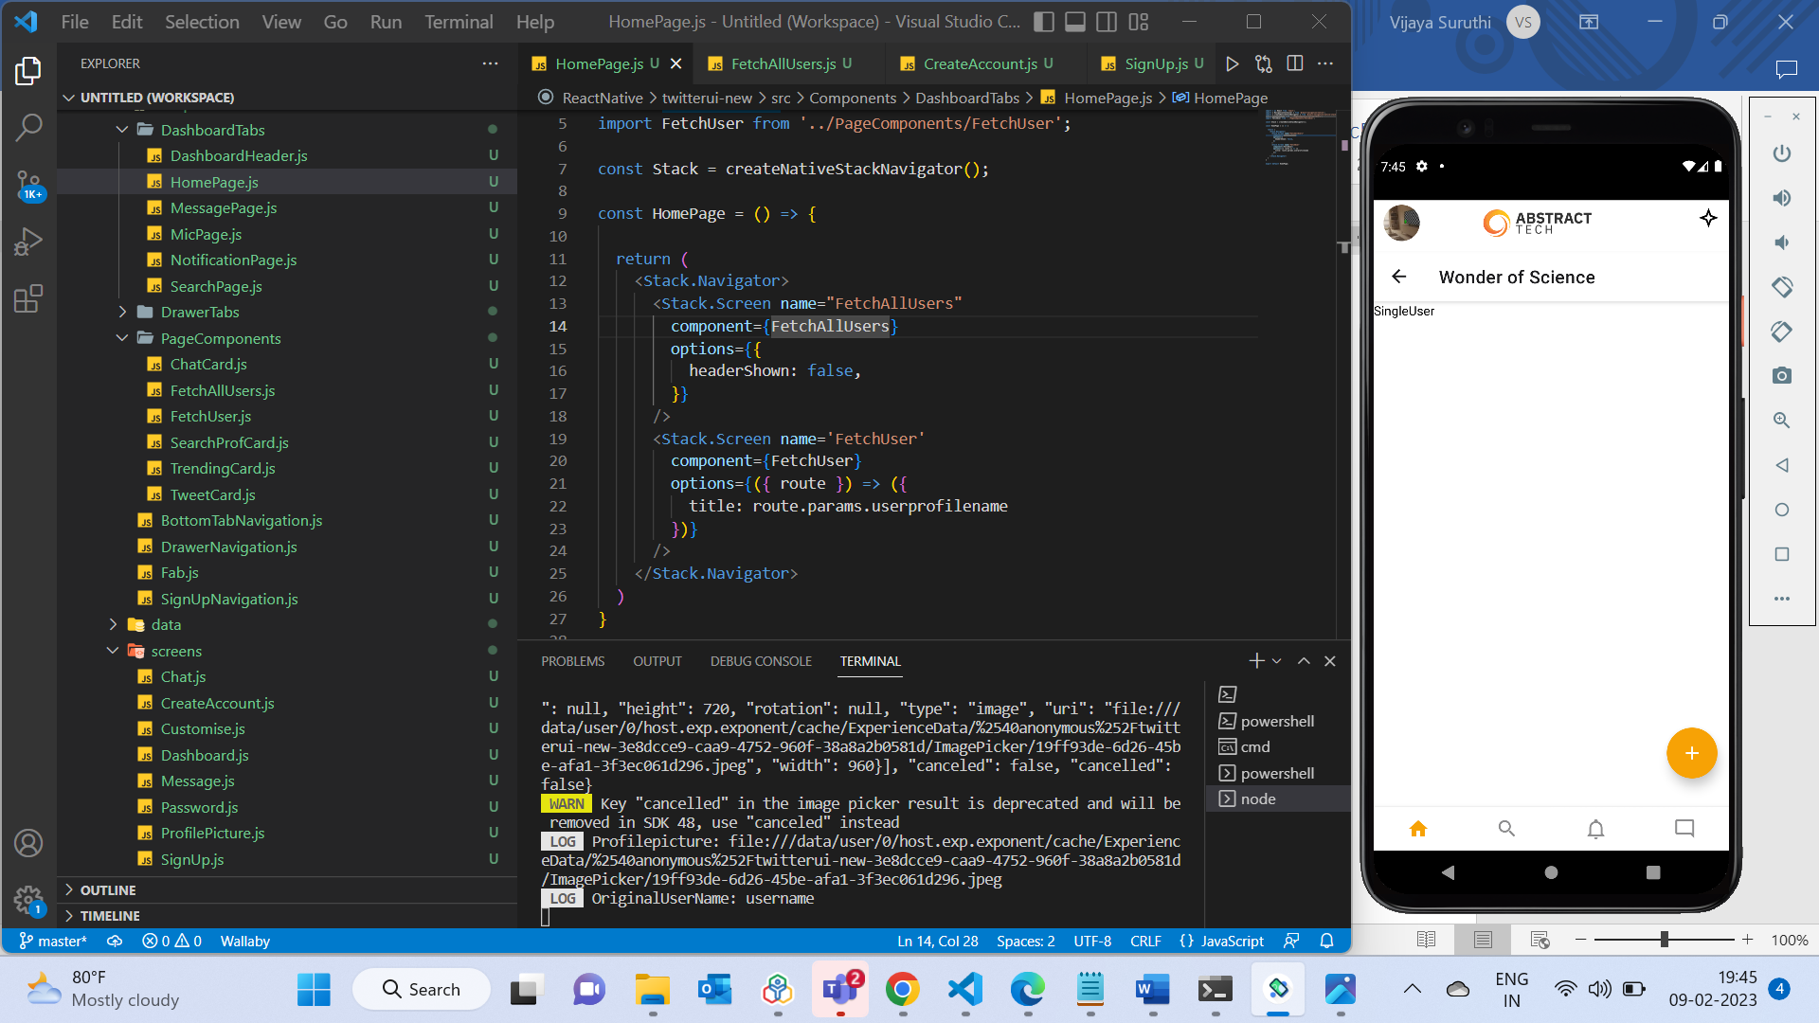

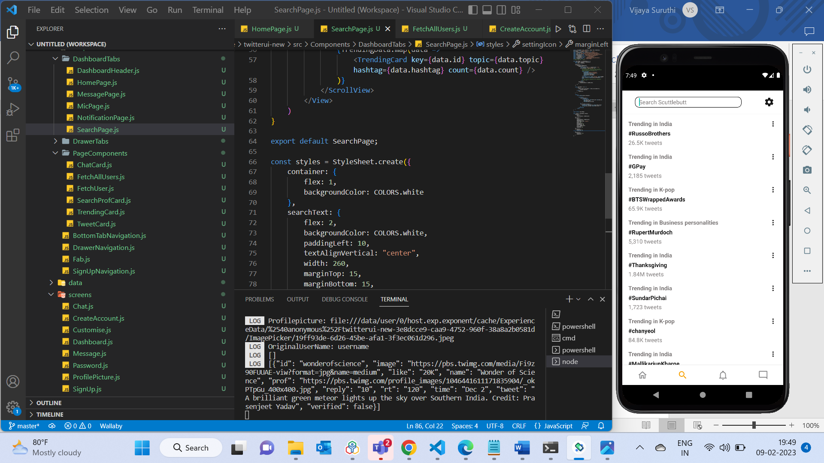

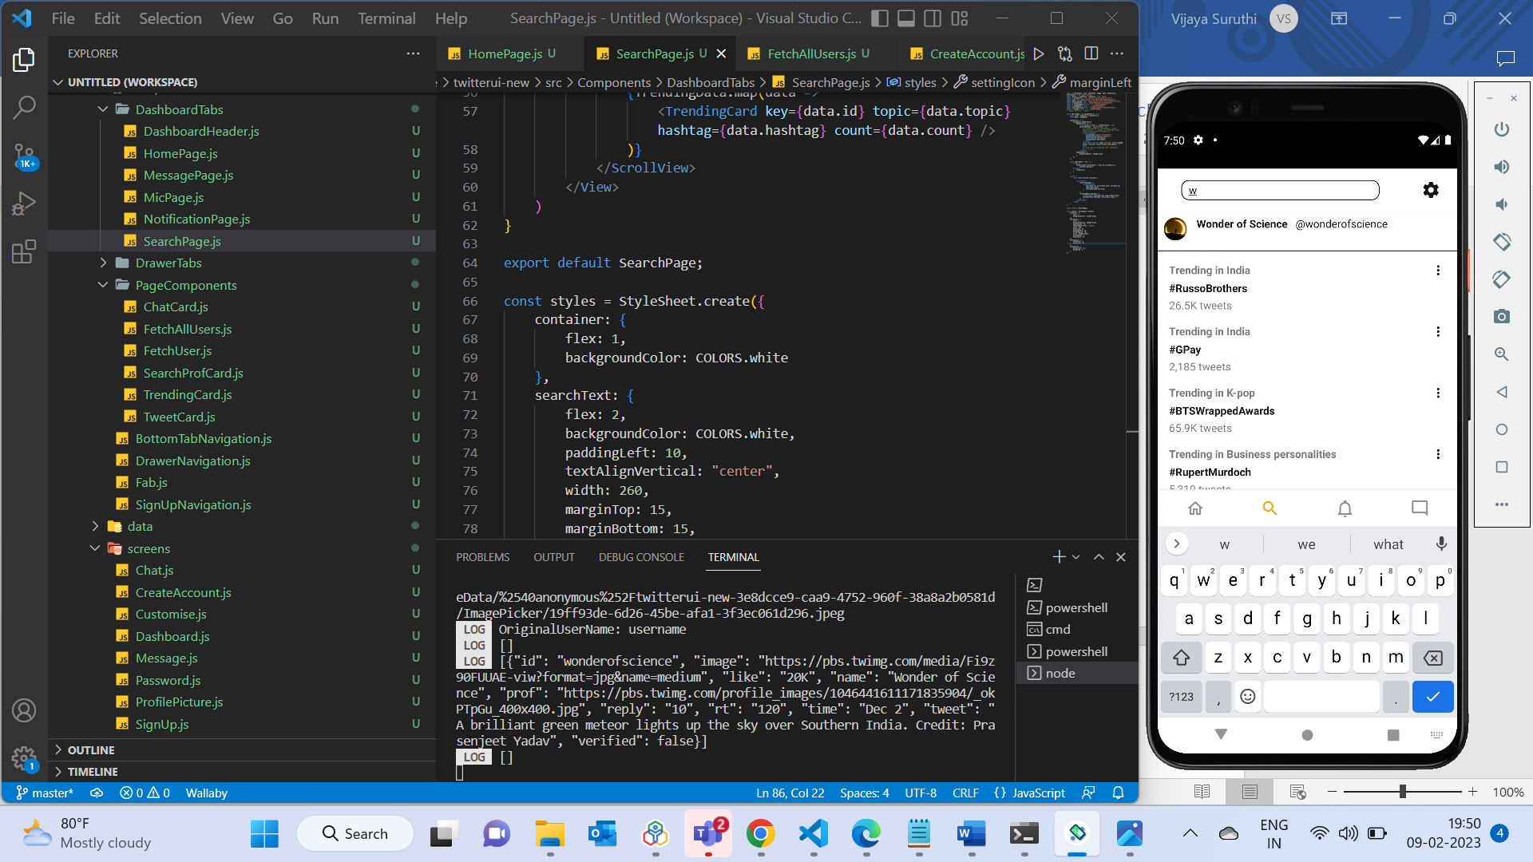

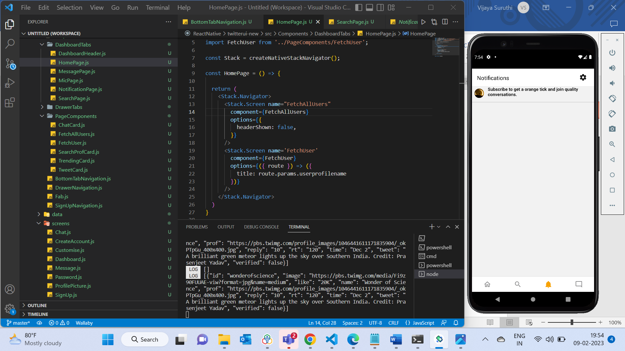

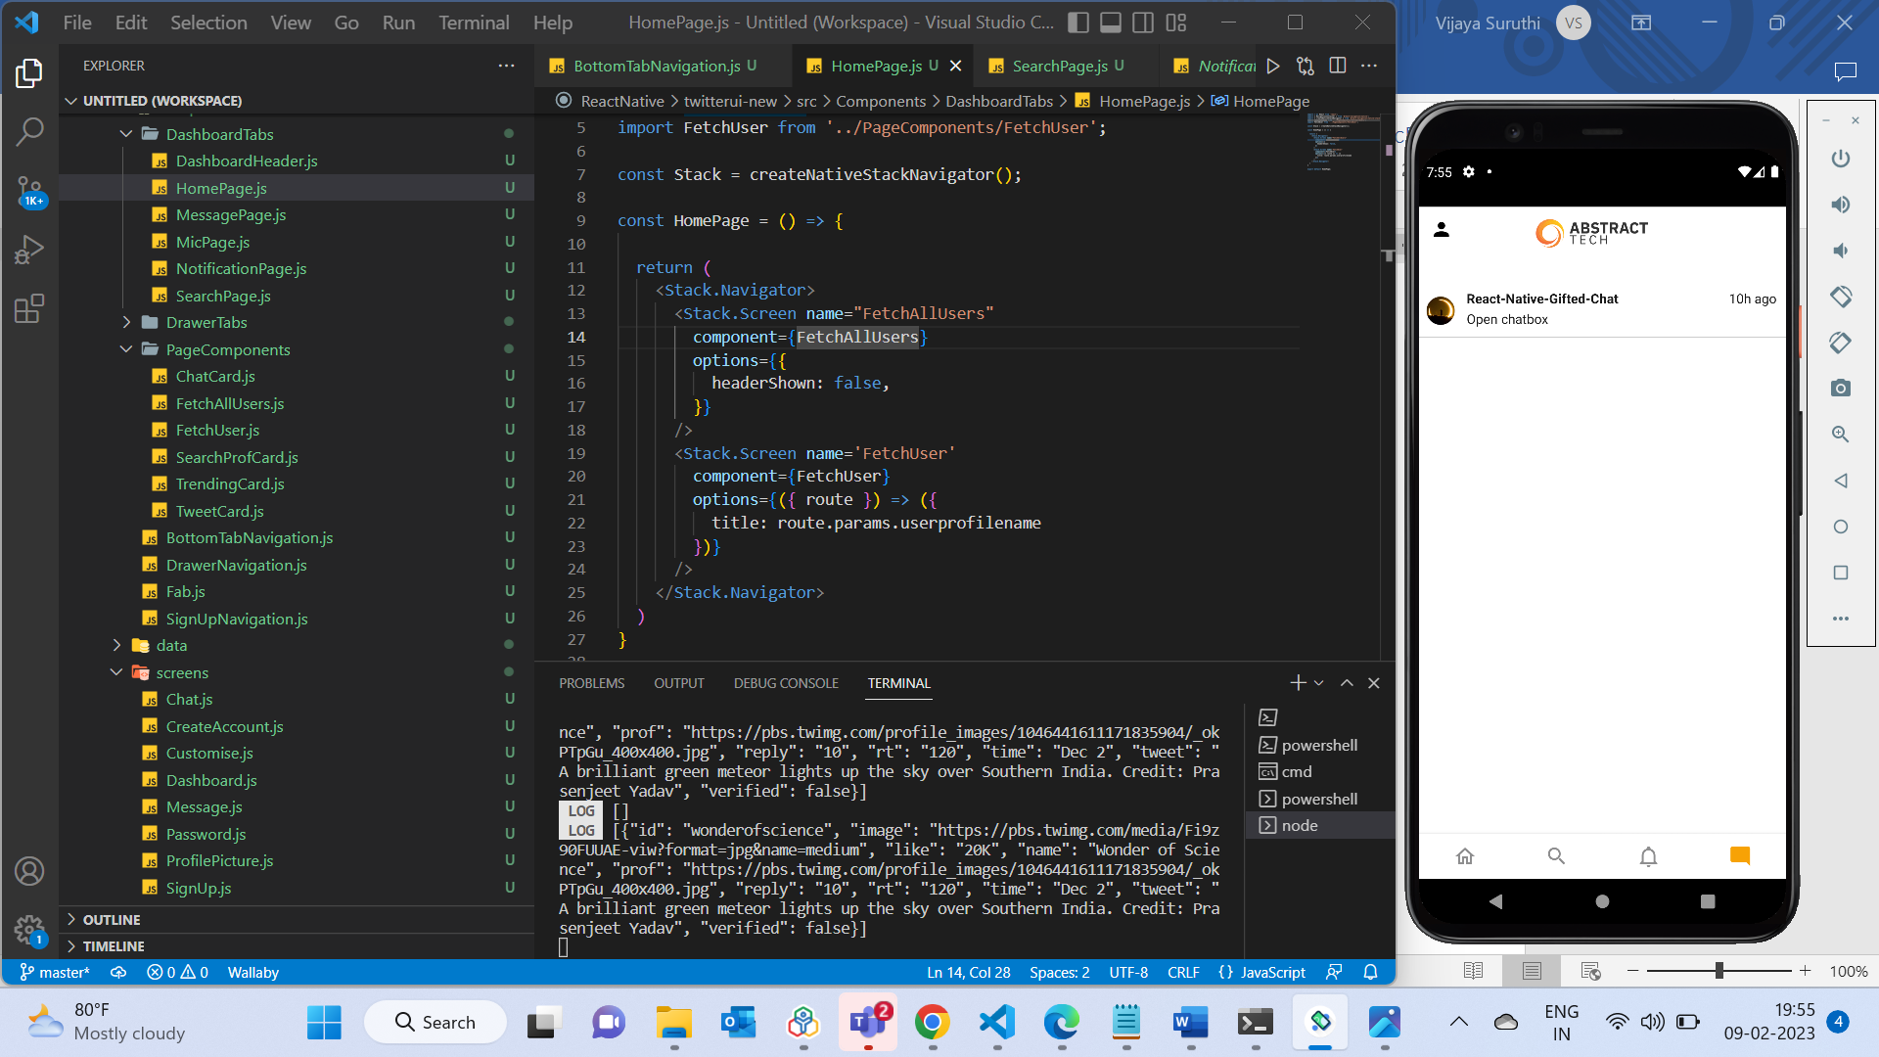

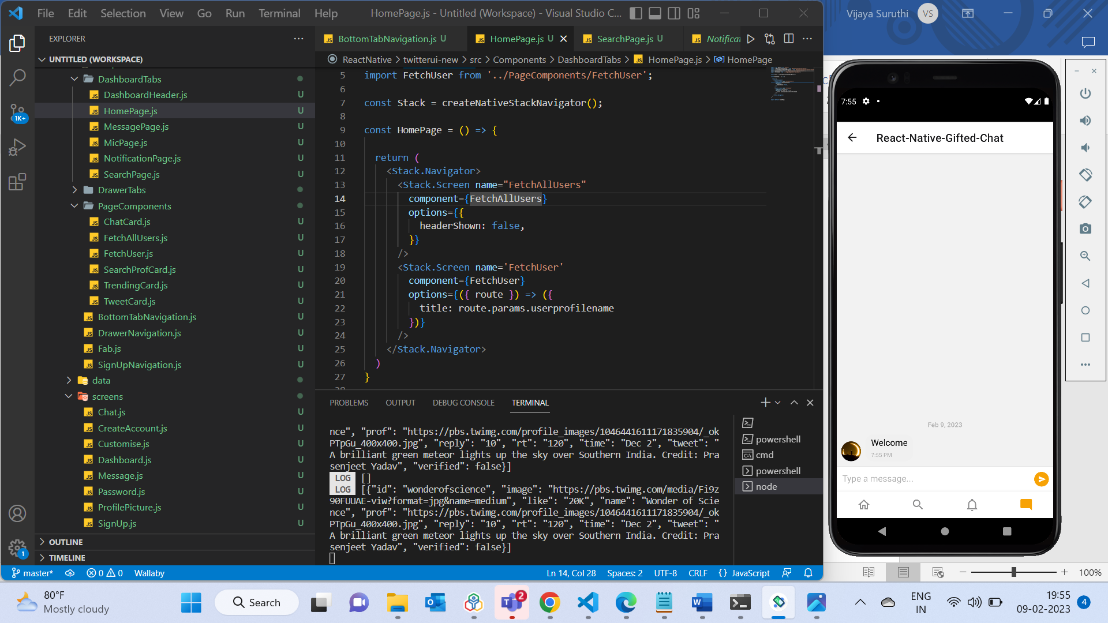

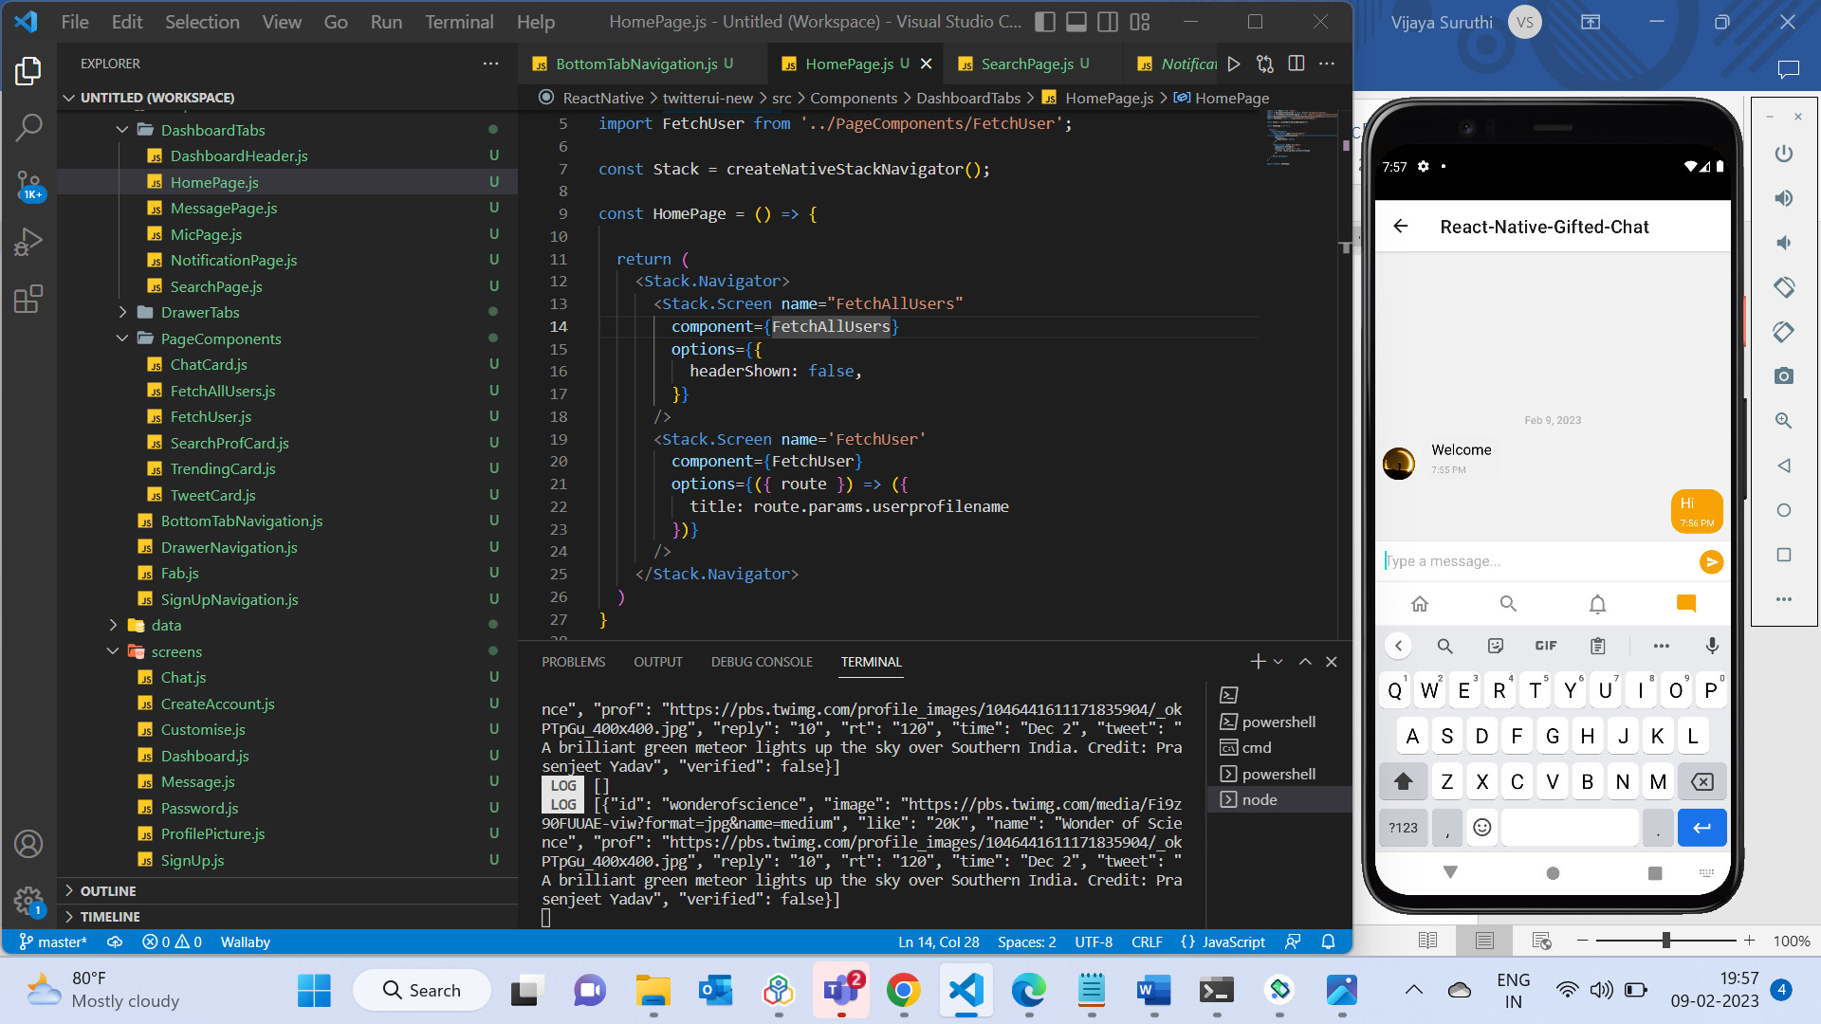

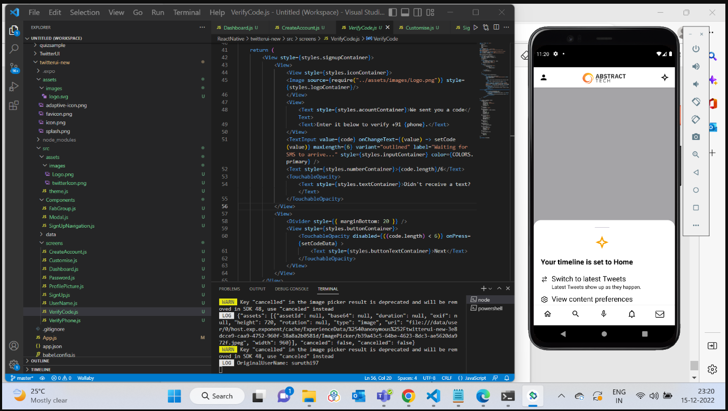

**Videos:**

Environment setup:

<https://www.youtube.com/watch?v=foOsorhsbIw>

Reference

<https://www.youtube.com/watch?v=ANdSdIlgsEw>

Camera

<https://www.youtube.com/watch?v=4WPjWK0MYMI>

Sample TODO list app (Passing props and Managing states)

<https://www.youtube.com/watch?v=0kL6nhutjQ8>

<https://www.youtube.com/watch?v=00HFzh3w1B8>

Sample food app UI reference (Async Storage, Managing states, Stack Navigation, Camera, Alert)

<https://www.youtube.com/watch?v=jA-R8bJRZPg&list=PLYBvEAka-q1ix8PZE_NiPaCy3lpChgGoa>